EDUTUNE: A STACKED ENSEMBLE APPROACH TO PREDICT STUDENT ENGAGEMENT AND PERFORMANCE IN EDUCATION
A PROJECT REPORT
Submitted by
BANALA ABHISHEK | 22UJ1A6604
BOMMINENI AVINASH | 22UJ1A6608
GANTA SIDDARTHA | 22UJ1A6618
TANVAR DILIP KUMAR | 22UJ1A6654

in partial fulfillment for the award of the degree
BACHELOR OF TECHNOLOGY
In
COMPUTER SCIENCE ENGINEERING
(Artificial Intelligence and Machine Learning)
Under the esteemed Guidance of
Mrs. A. Sukanya _{M.Tech}
Assistant Professor, Mrem

Department of Computer Science and Engineering (AI&ML)
MALLAREDDY ENGINEERING COLLEGE AND MANAGEMENT SCIENCES
(Autonomous)
(AFFILIATED TO JAWAHARLAL NEHRU TECHNOLOGICAL UNIVERSITY, HYDERABAD)
APPROVED BY AICTE- ACCREDITED BY NBA (CSE, IT, EEE, ECE) &NAAC
KISTAPUR, MEDCHAL – 501401
April 2026

MALLA REDDY ENGINEERING COLLEGE AND MANAGEMENT SCIENCES

Kistapur(V), Medchal(Dt)-501401
Department of Computer Science and Engineering (AI&ML)

Malla Reddy Engineering College and Management Sciences

BONAFIDE CERTIFICATE
This is to certify that the project report titled, “EDUTUNE: A STACKED ENSEMBLE APPROACH TO PREDICT STUDENT ENGAGEMENT AND PERFORMANCE IN EDUCATION” is a bonafide record of the project work done by
BANALA ABHISHEK | 22UJ1A6604
BOMMINENI AVINASH | 22UJ1A6608
GANTA SIDDARTHA | 22UJ1A6618
TANVAR DILIP KUMAR | 22UJ1A6654
with Hall ticket Numbers during the academic year 2025-2026.

Head of the Department  Signature: Name: Seal:  Date: | Guide Signature: Name:  Designation:  Date:

Submitted for the University Examination held on …………...

Internal Examiner  Signature: Name:  Designation:  Date: | External Examiner  Signature:  Name:  College / Designation: Date:

DECLARATION

We, undersigned, hereby declare that the project report “EDUTUNE: A STACKED ENSEMBLE APPROACH TO PREDICT STUDENT ENGAGEMENT AND PERFORMANCE IN EDUCATION”, submitted for partial fulfilment of the requirements for the award of degree of Bachelor of Technology in the Jawaharlal Nehru Technological University, Hyderabad is a bonafide work done by me under the guidance of Mrs. A. Sukanya M.Tech Assistant professor, Department of Computer Science and Engineering (AI&ML).
i. We have followed the guidelines provided by the Institute in preparing the report.
ii. We have conformed to the norms and guidelines given in the Ethical Code of Conduct of the Institute.
iii. Whenever we have used materials (data, theoretical analysis, figures, and text) from other sources, we have given due credit to them by citing them in the text of the report and giving their details in the references. Further, we have taken permission from the copyright owners of the sources whenever necessary.
We understand that any violation of the above will be a cause for disciplinary action by the institute and/or the University and can also evoke penal action from the sources that have thus not been properly cited or from whom proper permission has not been obtained. This report has not been previously formed the basis for the award of any degree, diploma, or similar title of any other University.

Place: Kistapur, Medchal
Date of Submission:

BANALA ABHISHEK | 22UJ1A6604
BOMMINENI AVINASH | 22UJ1A6608
GANTA SIDDARTHA | 22UJ1A6618
TANVAR DILIP KUMAR | 22UJ1A6654

ACKNOWLEDGEMENT
It gives us great pleasure to thank Mrs. A.Sukanya M.Tech Assistant Professor, Department of Computer Science and Engineering, for the constant support and guidance given to us throughout the course of this project. He/she has been a constant source of inspiration for us. We also take the opportunity to acknowledge the contribution of Professor and Head, Department of Computer Science and Engineering (AI&ML), for his support and assistance during the development of the project. We also take this opportunity to acknowledge the contribution of all faculty members of the department for their assistance and cooperation during the development of our project. We also thank all the Non-Teaching Staff of the Department who helped us in the course of the project. Last but not least, we acknowledge our friends for their encouragement in the completion of the project.

BANALA ABHISHEK | 22UJ1A6604
BOMMINENI AVINASH | 22UJ1A6608
GANTA SIDDARTHA | 22UJ1A6618
TANVAR DILIP KUMAR | 22UJ1A6654

INSTITUTE VISION
The aspiration is to emerge as a premier institution in technical education, producing competent engineers and management professionals who contribute to industry and society.

INSTITUTE MISSION
By Providing the Student Supporting Systems:

To impart updated pedagogical techniques with a supportive learning environment and state- of-the-art facilities.
By Training the Students as per the Industry Needs:

To cultivate a culture of interdisciplinary approach, problem solving, innovative ecosystem, and entrepreneurship by facilitating critical thinking, teamwork, and research-driven activities with hands-on learning.
By Educating the Students about the Society's Needs:
To instil ethical, social, and environmental values through community engagement, resulting in sustainable development of society.

QUALITY POLICY
Ensuring quality in Teaching and Training through appropriate student support systems, aligning the process towards the needs of Industry and Society.

DEPARTMENT VISION
To provide quality education that produces technologically & ethically strong engineers in the challenging digital world.

DEPARTMENT MISSION
MD 1 | To educate students in the emerging technology of Artificial Intelligence & Machine Learning.
MD 2 | To make students industry-ready by developing their analytical & technical skills.
MD 3 | To inculcate an academic environment for the students through self-learning, E-learning & technical practices

PROGRAM EDUCATIONAL OBJECTIVES (PEOs)

PEO1 | Graduate would be proficient with strong fundamentals in engineering, science, and technology to establish a successful career path in their life.
PEO2 | Graduate would be knowledgeable to plan, analyze, design, develop and test AI and ML-based solutions for real-world problems.
PEO3 | Graduate would be able to apply best practices in project building and exhibit leadership qualities with a strong personality.
PEO4 | Graduate would possess the capability to become an entrepreneur or to pursue higher studies.
PEO5 | Graduate would adhere to professional ethics and become a socially responsible human.

PROGRAM SPECIFIC OUTCOMES (PSOs)

PSO1 | Develop And Body-build Optimised Statement for Procedure Qualifier Utilise.
PSO2 | Use Implementation and Method in Artificial Intelligence and Machine Learning for the Resolution of Multidisciplinary Problems.

PROGRAM OUTCOMES (POs)
PO1 | Engineering knowledge: Apply the knowledge of mathematics, science, engineering fundamentals, and an engineering specialization to the solution of complex engineering problems.
PO2 | Problem analysis: Identify, formulate, review research literature, and analyse complex engineering problems reaching substantiated conclusions using first principles of mathematics, natural sciences, and engineering sciences.
PO3 | Design/development of solutions: Design solutions for complex engineering problems and design system components or processes that meet the specified needs with appropriate consideration for the public health and safety, and the cultural, societal, and environmental considerations.
PO4 | Conduct investigations of complex problems: Use research-based knowledge and research methods, including design of experiments, analysis and interpretation of data, and synthesis of the information to provide valid conclusions.
PO5 | Modern tool usage: Create, select, and apply appropriate techniques, resources, and modern engineering and IT tools including prediction and modelling to complex engineering activities with an understanding of the limitations.
PO6 | The engineer and society: Apply reasoning informed by the contextual knowledge to assess societal, health, safety, legal and cultural issues and the consequent responsibilities relevant to the professional engineering practice.
PO7 | Environment and sustainability: Understand the impact of the professional engineering solutions in societal and environmental contexts, and demonstrate the knowledge of, and need for sustainable development.

PO8 | Ethics: Apply ethical principles and commit to professional ethics and responsibilities and norms of the engineering practice.
PO9 | Individual and team work: Function effectively as an individual, and as a member or leader in diverse teams, and in multidisciplinary settings.
PO10 | Communication: Communicate effectively on complex engineering activities with the engineering community and with society at large, such as being able to comprehend and write effective reports and design documentation, make effective presentations, and give and receive clear instructions.
PO11 | Project management and finance: Demonstrate knowledge and understanding of the engineering and management principles and apply these to one’s own work, as a member and leader in a team, to manage projects and in multidisciplinary environments.
PO12 | Life-long learning: Recognize the need for, and have the preparation and ability to engage in independent and life-long learning in the broadest context of technological change.

COURSE OUTCOMES (For Project stage-2)

CO1 | Demonstrate the technical knowledge of their selected project topic.
CO2 | Undertake problem identification, formulation, and solution.
CO3 | Design engineering solutions to complex problems utilizing a systems approach.
CO4 | Work with practicing engineers
CO5 | Demonstrate the knowledge and skills acquired during the coursework

ABSTRACT
EDUTUNE presents a web-based machine learning system designed to analyze and predict student engagement and performance in music-oriented educational activities using a stacked ensemble approach. Built on the Flask framework and powered by a custom MLPipeline class, the application allows users to upload structured CSV datasets containing 19 attributes, such as Age, Gender, Engagement_Score, and Performance_Score, for exploratory data analysis (EDA), model training, and predictive evaluation. The pipeline automates data preprocessing, feature handling, and regression modeling using algorithms such as K-Nearest Neighbors, Support Vector Regressor, Decision Tree, and Stacking Regressor to enhance predictive accuracy. The system supports both single-instance and batch predictions, with outputs systematically stored in the file system. Leveraging Scikit-learn, Pandas, Matplotlib, and Joblib, the platform ensures reliable data processing, visualization, and model persistence. Architecturally, it follows a modular three-layer design, Client, Application, and Storage layers, supporting scalability and maintainability. Feasibility analysis confirms strong technical and economic viability, while acknowledging moderate operational and scheduling constraints related to user training and data validation. By integrating ensemble learning with an accessible web interface, EDUTUNE provides educators and researchers with a practical, data-driven tool to monitor academic engagement and improve performance outcomes.
Keywords: Music Education, Student Performance Prediction, Engagement Analysis, Machine Learning Model, Stacked Ensemble Regression, Musical Feature Analysis, Data Preprocessing, Educational Personalisation

INDEX
LIST OF FIGURES | i
LIST OF ABBREVIATIONS | ii

Chapter 1: Introduction |  |  | 1
 |  | 1.1 Introduction to the Project | 1
 |  | 1.2 Background of the study | 1
 |  | 1.3 Problem Statement | 1
 |  | 1.4 Objectives of the Project | 2
 |  | 1.5 Scope of the Report | 2
 |  | 1.6 Organization of the Report | 3
Chapter 2: Literature Survey |  |  | 4
 |  | 2.1 Introduction | 4
 |  | 2.2 Review of the Existing Systems | 11
 |  | 2.3 Limitations of Existing Systems | 12
 |  | 2.4 Proposed System Overview | 13
Chapter 3: System Analysis and Design |  |  | 15
 |  | 3.1 System Requirements | 15
 |  | 3.2 Feasibility Study | 17
 |  | 3.3 System Architecture | 17
 |  | 3.4 Data Flow Diagram (DFD) | 30
 |  | 3.5 UML Diagrams | 30
 |  | 3.6 Database Design / ER Diagrams | 35
Chapter 4: Implementation |  |  | 36
 |  | 4.1 Tools and Technologies Used | 36
 |  | 4.2 Module Description | 37
 |  | 4.3 Algorithm / Methodology | 38
 |  | 4.4 System Implementation | 39
Chapter 5: Source Code |  |  | 40
Chapter 6: Results and Discussion |  |  | 63
 |  | 6.1 System Testing | 63
 |  | 6.2 Output Screens | 64
 |  | 6.3 Performance Analysis | 68
 |  | 6.4 Advantages of the System | 68
Chapter 7: Conclusion and Future Scope |  |  | 70
 | 7.1 Conclusion |  | 70
 | 7.2 Future Enhancements |  | 70
References |  |  | 71

LIST OF FIGURES

Figure  No. | Particulars | Page No.
1. | Figure 2.2.1 Existing System Architecture | 11
2. | Figure 3.3.1 System Architecture of EduTune | 19
3. | Figure 3.3.1.1 Backend Architecture of Proposed Ensemble Model | 22
4. | Figure 3.3.2.1 Data Preprocessing of Hybrid Ensemble Model | 24
5. | Figure 3.3.3.1 Internal Operations workflow of KNN Model | 26
6. | Figure 3.3.3.2 Internal Operations workflow of SVR Model | 27
7. | Figure 3.3.3.3 Internal Operations workflow of Decision Tree Model | 28
8. | Figure 3.3.3.4 Internal Operations workflow of Axis Forest Model | 29
9. | Figure 3.4.1 Data Flow Diagram | 30
10. | Figure 3.5.1.1 Use Case Diagram | 31
11. | Figure 3.5.2.1 Class Diagram | 31
12. | Figure 3.5.3.1 Activity Diagram | 32
13. | Figure 3.5.4.1 Sequence Diagram | 33
14. | Figure 3.5.5.1 Deployment Diagram | 34
15. | Figure 3.5.6.1 Component Diagram | 35
16. | Figure 3.6.1 ER Diagram of EduTune | 35
17. | Figure 5.2.1 Frontend Dashboard of EduTune | 64
18. | Figure 5.2.2 Exploratory Data Analysis summary of EduTune | 65
19. | Figure 5.2.3 Model Performance Analysis | 65
20. | Figure 5.2.4 Data Visualization (EDA Graphs) | 66
21. | Figure 5.2.5 Prediction Interface for Single Input Analysis | 67
22. | Figure 5.2.6 Prediction of the Test Data | 67

LIST OF ABBREVIATIONS

Abbreviation | Full Form
ML | Machine Learning
KNN | K-Nearest Neighbors
SVR | Support Vector Regressor
DTR | Decision Tree Regressor
LR | Linear Regression
RFR | Random Forest Regressor
MSE | Mean Squared Error
MAE | Mean Absolute Error
PS | Performance Score
ES | Engagement Score

CHAPTER 1
INTRODUCTION
  - Introduction to the Project
EDUTUNE is a web-based machine learning system designed to analyze and predict student engagement and academic performance using a stacked ensemble learning approach. With the rapid growth of digital education platforms, large volumes of student interaction data are generated, including behavioral and performance-related attributes. However, this data often remains underutilized in improving learning outcomes.
The proposed system leverages advanced machine learning algorithms such as K-Nearest Neighbors (KNN), Support Vector Regressor (SVR), Decision Tree Regressor, and a Stacking Regressor to provide accurate predictions of engagement and performance. The system is implemented using a Flask-based web application that enables users to upload datasets, perform exploratory data analysis (EDA), train models, and generate predictions.
By integrating predictive analytics with an accessible interface, EDUTUNE aims to assist educators, institutions, and learners in making data-driven decisions to enhance academic success and personalized learning experiences.
1.2 Background of the Study
The study behind this project is based on the growing need for data-driven solutions in the education sector to improve student performance and engagement. Educational institutions and online learning platforms generate large amounts of student data, but this data is often not effectively utilized for decision-making. By applying machine learning techniques, institutions can analyze student behavior, identify learning patterns, and provide timely interventions to support academic success. The EDUTUNE system enables automated analysis and prediction, helping educators and administrators improve teaching strategies and student outcomes. Additionally, this approach can benefit educational platforms, researchers, and organizations by providing scalable, cost-effective, and intelligent solutions for academic performance monitoring and personalized learning.
1.3 Problem Statement
The main problem is the absence of a structured, data-driven mechanism to systematically analyze and interpret large-scale student engagement and performance data in modern educational environments. Institutions generate extensive behavioral and academic data, yet lack effective tools to identify hidden patterns, detect early signs of disengagement, and establish measurable indicators of student engagement beyond traditional test scores. This limitation restricts timely intervention, weakens the ability to evaluate teaching effectiveness, and prevents meaningful correlation analysis between engagement factors and academic outcomes. As a result, decision-making remains reactive rather than predictive, hindering both student success and institutional performance optimization.
1.4 Objective of the Project
The main objective of the EDUTUNE project is to develop an intelligent machine learning-based system that can analyze and predict student engagement and academic performance effectively. The system aims to identify disengaged or at-risk students at an early stage, enabling timely academic support and intervention. It focuses on transforming abstract student behaviors into measurable engagement indicators, which helps in better understanding learning patterns. Additionally, the project seeks to improve teaching strategies by providing data-driven insights and supporting personalized learning by adapting to individual student performance and interaction patterns. Overall, EDUTUNE enhances institutional decision-making by utilizing predictive analytics to improve educational outcomes and optimize learning processes.
1.5 Scope of the Project

The scope of this project includes the design, development, and implementation of a predictive analytics system for student engagement and performance. The system focuses on structured datasets containing multiple attributes related to student demographics, behavior, and academic results.

Technical Scope
- Implementation of machine learning models (KNN, SVR, Decision Tree, Stacking Regressor)
- Data preprocessing, including handling missing values and encoding categorical variables
- Visualization through EDA techniques such as plots and heatmaps
- Model training, evaluation, and prediction

Application Scope
- Educational institutions for monitoring student performance
- Online learning platforms for engagement analysis
- Researchers for studying learning behavior patterns

1.6 Organisation of the Report
This B.Tech project report on “EDUTUNE: A Stacked Ensemble Approach to Predict Student Engagement and Performance in Education” follows a standard academic structure comprising preliminary sections, multiple chapters, and references. The report presents the complete design, development, and evaluation of a machine learning-based system for predicting student engagement and performance.
Preliminary Sections
The preliminary part of the report includes the cover page, bonafide certificate, declaration by all project members, acknowledgements to the project guide and faculty, institute, and department vision and mission statements, program educational objectives (PEOs), program specific outcomes (PSOs), program outcomes (POs), and course outcomes (COs). It also includes the abstract summarizing the EDUTUNE system, list of figures, list of abbreviations, list of tables, and the index of the report.

CHAPTER 2
LITERATURE SURVEY
2.1 Introduction
The literature survey reviews existing research on student engagement analysis and academic performance prediction in modern educational systems. With the rise of online learning platforms, large volumes of student interaction data are generated, including behavioral and performance-related information. Researchers have applied various techniques such as statistical analysis, machine learning, and deep learning to extract meaningful insights from this data. Studies show that student engagement is a key factor influencing academic success, using features like participation, video interaction, and assessment performance. Machine learning models such as KNN, SVM, Decision Trees, and Neural Networks have been widely used for prediction tasks. These methods help in identifying patterns and forecasting student outcomes effectively. However, many existing systems lack real-time prediction capabilities and fail to utilize multiple features efficiently. Most approaches rely on single models, which may reduce prediction accuracy. Additionally, they do not fully capture the complex relationship between engagement and performance. To address these limitations, the EDUTUNE system adopts a stacked ensemble approach. This method combines multiple models to improve prediction accuracy and reliability. Thus, this chapter analyzes existing work to identify research gaps and justify the proposed system.
2.1.1 Literature Survey
Guo, Kim J., Rubin R. et al. [1] (2014): This study analyzed student engagement while watching videos using time spent and assessment responses. Findings showed shorter videos were more engaging than long lectures. The research emphasized concise and interactive content for better learning.
Bonafini et al. [2] (2017): The authors analyzed MOOC engagement using logistic regression with forum and video data. Results showed discussion participation and video usage improve achievement. The study highlighted active participation as key to success.
Ramesh et al. [3] (2017): This study predicted engagement using discussion forum posts and statistical methods. It showed engagement depends on factors like course design and demographics. The research emphasized the complexity of modeling engagement.
Manwaring et al. [4] (2017): The authors studied engagement in blended classrooms using cross-lagged modeling. Results showed course design and student perception influence engagement. The study highlighted instructional design importance.
Mutahi et al. [5] (2017): This study examined the relationship between engagement and exam performance. Results showed strong positive correlation between material interaction and grades. It emphasized continuous participation improves outcomes.
Aguiar et al. [6] (2014): The researchers developed an early-warning system using engagement features. Results showed participation frequency predicts dropout risk effectively. The study highlighted predictive analytics for early intervention.
Thomas and Jayagopi et al. [7] (2017): This work used ML to detect engagement via facial expressions and eye gaze. Results showed accurate real-time engagement prediction. The study emphasized non-verbal cues in smart classrooms.
Atherton et al. [8] (2017): The authors found strong correlation between resource access and performance. Frequent content usage improved academic scores. The study emphasized engagement with learning materials.
Ding et al. [9] (2018): The study explored gamification effects on engagement in online forums. Results showed increased participation using points and badges. It highlighted gamification as a motivational strategy.
Wells et al. [10] (2016): This research analyzed LMS engagement and performance data. Engagement increased near exams and correlated with performance. The study highlighted predictive role of engagement patterns.
Pardo et al. [11] (2016): This study showed online activity participation improves exam performance. However, some engagement types showed weaker correlation. It emphasized meaningful interaction for learning success.
Hamid et al. [12] (2018): The researchers used ML models like SVM and KNN to predict engagement. Results showed reliable detection of student activity patterns. The study highlighted ML effectiveness in analytics.
Rodgers et al. [13] (2008): This study analyzed interaction and performance in e-learning systems. Results showed strong correlation between interaction and achievement. It validated digital engagement as a success factor.
Bote-Lorenzo et al. [14] (2017): The authors predicted engagement drops using machine learning in MOOCs. Results identified at-risk students through behavior analysis. The study emphasized proactive monitoring.
Cole et al. [15] (2021): This study identified student isolation as a barrier in online learning. It suggested collaboration and communication to improve engagement. The research highlighted social presence importance.
Ali and Dmour et al. [16] (2021): The study used surveys and CNN models to analyze engagement. Results showed preference for e-learning and practice-based learning. It emphasized combining analytics with student feedback.
Semerci et al. [17] (2020): This study used CNNs to generate heat maps of engagement and performance. Results showed deep learning captures complex patterns. It highlighted advanced analytics in education.
Gray and Perkins et al. [18] (2019): This research showed low interaction leads to higher failure risk. It emphasized early engagement over mere attendance. The study highlighted importance of active participation.
Lu and Cutumisu et al. [19] (2022): The study analyzed attendance and performance in TEL courses. Results showed motivation matters more than attendance. It emphasized quality of engagement.
Yang et al. [20] (2022): The authors used deep neural networks for performance prediction. Results showed strong background students engage more. The study highlighted multi-feature data-driven prediction.
P. Nayak [21] (2023): This study predicted students’ academic performance using machine learning classification models. Various algorithms like decision trees and SVM showed high accuracy. It emphasized preprocessing and feature selection for better prediction and early intervention.
Hernández-Blanco et al. [22] (2019): This study reviewed deep learning approaches in educational data mining. It showed deep learning outperforms traditional methods in handling large datasets. The research highlighted automated feature extraction for improved predictions.
Namoun and Alshanqiti [23] (2021): This study reviewed data mining and learning analytics techniques for student prediction. It showed combining multiple approaches improves reliability. The research emphasized integrating behavioral and academic data.
Albreiki et al. [24] (2021): This study reviewed machine learning techniques for student performance prediction. Ensemble models performed better than single models. It highlighted challenges like data imbalance and the need for quality data.
Nawang et al. [25] (2021): This study reviewed prediction techniques used in educational systems. Machine learning methods were found effective and scalable. It emphasized real-time systems and multi-source data integration.
Baashar et al. [26] (2022): This study used Artificial Neural Networks to predict academic performance. ANN models showed higher accuracy than traditional methods. It highlighted neural networks’ ability to model complex relationships.
Biggs et al. [27] (2022): This study focused on improving teaching quality through constructive alignment. It showed that structured teaching improves engagement and learning. It emphasized student-centered learning approaches.
Kotsiantis et al. [28] (2004): This study applied machine learning techniques in distance learning environments. It showed data mining can identify at-risk students effectively. It emphasized early prediction for timely intervention.
Gong et al. [29] (2011): This study compared knowledge tracing and performance factor analysis models. Optimized models improved prediction accuracy of student learning. It emphasized modeling learning over time.
Corbett and Anderson [30] (1994): This study introduced the knowledge tracing model using probabilistic methods. It accurately tracked student learning progress over time. It forms the foundation for modern tutoring systems.
Hernández et al. [31] (2020): This study used process mining to assess teamwork in collaborative projects. It analyzed interaction logs to evaluate contributions. It improved fairness and accuracy in group assessments.
Pisner and Schnyer [32] (2020): This study explained Support Vector Machines for classification and regression. It showed SVM works well in high-dimensional data. It highlighted kernel functions for handling non-linear problems.
Bendangnuksung [33] (2018): This study used deep neural networks for predicting student performance. It showed higher accuracy compared to traditional methods. It emphasized automatic feature extraction.
Raihana and Farah Nabilah [34] (2018): This study classified students using SVM based on quality of life and performance. It showed effective categorization of student groups. It highlighted the impact of lifestyle factors.
Hasan [35] (2018): This study used decision tree algorithms for student performance prediction. It provided clear and interpretable results. It emphasized feature selection for accuracy improvement.
Divyabharathi and Someswari [36] (2018): This study used Naïve Bayes for academic performance prediction. It showed efficient and fast classification with good accuracy. It highlighted simplicity of probabilistic models.
Francis and Sasidhar Babu [37] (2019): This study used a hybrid data mining approach for prediction. Hybrid models performed better than single algorithms. It emphasized combining techniques for better insights.
Gütter et al. [38] (2022): This study analyzed training data size impact on deep learning models. Larger datasets improved accuracy and robustness. It emphasized handling noisy and missing data.
Ahmed et al. [39] (2023): This study reviewed deep learning techniques and their applications. It showed high performance but noted challenges like cost and data needs. It emphasized deep learning’s importance in prediction tasks.
Zorić [40] (2019): This study used neural networks to predict student success. It showed effective modeling of complex relationships. It emphasized AI-based decision-making in education.
Gamao and Gerardo et al. [41] (2019): He proposed a dropout prediction model using a modified firefly algorithm. It improved accuracy using optimization on academic and behavioral data. The study highlighted nature-inspired algorithms in education.
Gil et al. [42] (2020): He predicted student dropout indicators using data mining techniques. Machine learning models identified at-risk students effectively. The study emphasized early intervention.
Singh and Pal et al. [43] (2020): He applied machine learning algorithms for student performance prediction. Models like decision trees and neural networks showed reliable results. It highlighted importance of algorithm selection.
Waheed et al. [44] (2020): He used deep learning on VLE big data for performance prediction. Models captured complex interaction patterns effectively. It emphasized big data analytics in education.
Tsiakmaki et al. [45] (2020): He applied transfer learning using deep neural networks for prediction. It improved performance with limited data. The study showed better generalization.
Beckham et al. [46] (2023): He analyzed factors affecting student performance using ML methods. Multiple features influenced academic success. It emphasized data-driven decision-making.
Lau et al. [47] (2019): He used artificial neural networks for prediction and classification. Models captured complex relationships in student data. It showed high prediction accuracy.
Asaad and Ali [48] (2019): He explained backpropagation neural networks with sigmoid functions. It highlighted learning in multi-layer networks. The study focused on neural network fundamentals.
Pallathadka et al. [49] (2023): He compared various ML algorithms for student performance prediction. Ensemble models performed better than single models. It emphasized selecting suitable algorithms.
Alyahyan and Düştegör et al. [50] (2020): He reviewed methods for predicting academic success in higher education. ML techniques were found effective. It provided best practices and future directions.
Gimenez et al. [51] (2018): He studied the impact of social development on student performance. Better socio-economic conditions improved outcomes. It emphasized external factors in education.
Antonopoulou et al. [52] (2020): He analyzed the effect of diet on academic performance and mental health. Healthy diet improved both learning and well-being. It highlighted lifestyle influence.
Agnafors et al. [53] (2021): He studied mental health impact on academic performance over time. Results showed strong influence on success. It emphasized early interventions.
Bruffaerts et al. [54] (2018): He analyzed mental health issues among college freshmen. Problems negatively affected academic performance. It highlighted need for support systems.
Moubayed et al. [55] (2020): He used K-means clustering to analyze student engagement. It identified engagement levels affecting performance. It emphasized data-driven learning analysis.
Batool et al. [56] (2023): He reviewed data mining techniques for student performance prediction. ML and DL methods were widely used. It highlighted future trends.
Hao et al. [57] (2022): He used Bayesian networks for MOOC performance prediction. It provided personalized recommendations. It emphasized adaptive learning.
Huang et al. [58] (2022): He used behavior dynamics to detect at-risk students early. It analyzed interaction patterns over time. It emphasized timely intervention.
Kukkar et al. [59] (2023): He predicted performance using emotional and behavioral data. ML improved accuracy with multi-dimensional features. It highlighted emotional factors.
Abdulkader et al. [60] (2023): He proposed EBSAAS using face detection and deep learning. It monitored attentiveness in real time. It emphasized smart education systems.
Souai et al. [61] (2022): He proposed a BLSTM-based deep learning model to predict at-risk students. It captured sequential learning patterns effectively. The study showed improved prediction accuracy using temporal data.
Romero et al. [62] (2013): He applied web usage mining to predict student final marks in Moodle courses. It analyzed interaction data and learning activities. The study showed strong correlation between usage patterns and performance.
Ade and Deshmukh [63] (2014): He used an incremental ensemble classifier to predict students’ career choices. It combined multiple models for better accuracy. The study highlighted ensemble learning effectiveness.
Nielsen [64] (2020): He analyzed student video viewing habits in flipped classrooms. It showed viewing patterns influence learning outcomes. The study emphasized video engagement importance.
An and Bir [65] (2018): He studied student interaction with online videos in hybrid courses. It showed engagement patterns affect performance. The research highlighted importance of video analytics.
Hellas et al. [66] (2018): He conducted a systematic review on academic performance prediction. It analyzed various ML techniques and datasets. The study highlighted research trends and challenges.
Xu et al. [67] (2017): He proposed progressive prediction models for student performance. It updated predictions over time using new data. The study improved accuracy in long-term prediction.
Pujianto et al. [68] (2020): He used KNN and C4.5 with SMOTE-balanced data for prediction. It handled class imbalance effectively. The study improved classification performance.
Souai et al. [69] (2022): He proposed a BLSTM-based model for predicting at-risk students. It captured sequential dependencies in learning data. The study showed better accuracy than traditional models.
Romero et al. [70] (2013): He used web mining techniques to analyze Moodle student data. It identified patterns influencing final grades. The study emphasized importance of LMS data.
Ade and Deshmukh [71] (2014): He applied ensemble classifiers for predicting career choices. It improved prediction performance through model combination. The study highlighted hybrid approaches.
Nielsen [72] (2020): He studied video viewing behavior in flipped learning environments. It showed engagement varies with video design. The study emphasized interactive content.
An and Bir [73] (2018): He analyzed interaction with online instructional videos. It showed usage patterns impact learning outcomes. The study highlighted importance of engagement tracking.
Hellas et al. [74] (2018): He reviewed performance prediction methods in education. It identified key algorithms and evaluation techniques. The study highlighted need for improved models.
Xu et al. [75] (2017): He developed progressive prediction techniques for student performance. It improved forecasting using continuous updates. The study emphasized dynamic prediction models.
Pujianto et al. [76] (2020): He applied KNN and decision tree algorithms on balanced datasets. It improved prediction accuracy using SMOTE. The study handled imbalanced data effectively.
Dermy et al. [77] (2022): He modeled student digital behavior using behavioral primitives. It analyzed interaction patterns for insights. The study highlighted behavior-based prediction.
Mubarak et al. [78] (2022): He used graph convolutional networks to model student performance. It captured relationships between features. The study improved prediction using graph-based learning.
Bolliger and Martin [79] (2018): He analyzed perceptions of student engagement strategies in online learning. It showed importance of interaction and communication. The study emphasized engagement design.
Alsulami et al. [80] (2023): He enhanced student performance prediction using ensemble techniques. It combined multiple models for better accuracy. The study highlighted ensemble learning effectiveness.
2.2 Review of Existing System
Existing systems for analyzing student engagement and academic performance primarily rely on traditional methods such as manual evaluation, basic statistical analysis, and simple machine learning techniques. Educational institutions commonly use metrics like attendance, exam scores, assignment submissions, and participation records to assess student performance. In online learning environments, platforms track activities such as video views, quiz attempts, and discussion forum interactions to estimate engagement levels. While these systems provide useful insights, they are often limited in scope and fail to capture the complete learning behavior of students. Most existing approaches depend on single-model predictions and lack the ability to analyze complex relationships between multiple factors affecting student performance. Additionally, these systems are not fully automated and often require manual interpretation, which reduces efficiency and accuracy.
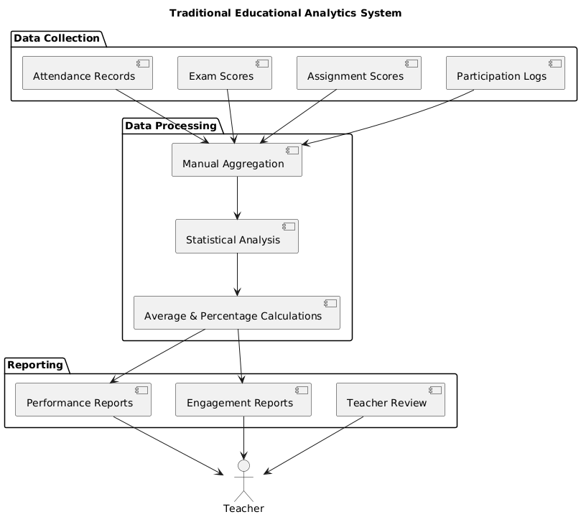
Figure 2.2.1: Existing System Architecture.
Working of Existing Systems
The workflow of existing systems typically involves:
- Data Collection:
Student data such as attendance, grades, assignment submissions, and interaction logs are collected from learning management systems or classroom records.
- Basic Data Analysis:
The collected data is analyzed using simple statistical methods like averages, percentages, and rankings to evaluate performance.
- Engagement Tracking:
Online platforms monitor activities such as video watching time, quiz participation, and discussion forum usage to estimate engagement levels.
- Single Model Prediction:
Machine learning models like KNN, SVM, or Decision Trees are sometimes used individually to predict student performance based on selected features.
- Reporting and Decision Making:
Results are presented in the form of reports or dashboards, and educators manually interpret the data to make decisions regarding student support or teaching strategies.
2.3 Limitations of Existing System
- Limited analysis scope, focusing mainly on basic metrics like attendance and exam scores.
- Lack of real-time prediction for identifying at-risk or disengaged students early.
- Dependence on manual data interpretation, leading to delayed decision-making.
- Low prediction accuracy due to reliance on single machine learning models.
- Limited utilization of behavioral and interaction-based data from online platforms.
- Difficulty in handling large-scale educational datasets efficiently.
- Lack of personalized learning recommendations for individual students.
- Poor scalability in traditional systems when applied to multiple courses or institutions.
- High chances of human error in data handling and evaluation processes.
- Insufficient integration with user-friendly interfaces for practical usage.
- Inability to provide proactive interventions, resulting in reactive academic support.

2.4 Proposed System Overview
The proposed system, EDUTUNE, is a web-based machine learning application designed to analyze and predict student engagement and academic performance using a stacked ensemble approach. Unlike traditional systems, it utilizes multiple machine learning models such as K-Nearest Neighbors (KNN), Support Vector Regressor (SVR), Decision Tree Regressor, and a Stacking Regressor to improve prediction accuracy. The system processes structured student datasets and extracts meaningful insights through data preprocessing, exploratory data analysis (EDA), and predictive modeling. It provides a user-friendly interface built using Flask, allowing users to upload datasets, visualize data, train models, and generate predictions efficiently.
Working of the Proposed System
The workflow of the proposed system includes:
- Data Collection:
Users upload student datasets in CSV format containing various attributes such as age, engagement score, and performance score.
- Data Preprocessing:
The system cleans the data by handling missing values, encoding categorical variables, and normalizing features for better model performance.
- Exploratory Data Analysis (EDA):
Visualizations such as graphs and heatmaps are generated to understand patterns and relationships in the data.
- Model Training:
machine learning models (KNN, SVR, Decision Tree) are trained on the dataset.
- Stacked Ensemble Learning:
A stacking regressor combines predictions from multiple models to enhance overall accuracy and reliability.
- Prediction:
The system provides both single and batch predictions for student engagement and performance.
- Result Visualization:
Outputs are displayed through dashboards and downloadable reports for easy interpretation.
Advantages of the Proposed System
The proposed EDUTUNE system overcomes limitations of traditional methods and provides several key improvements:
- Uses a stacked ensemble approach combining multiple models to improve prediction accuracy.
- Provides meaningful insights from student data to support better academic decisions.
- Identifies disengaged or at-risk students at an early stage for timely intervention.
- Reduces manual effort by automating preprocessing, analysis, and prediction tasks.
- Can handle large datasets and multiple users efficiently without performance degradation.
- Enables both individual and bulk data predictions for practical usability.
- Provides graphical insights through EDA for a better understanding of data patterns.
- Saves trained models for future use, reducing retraining time.
- Helps in enhancing teaching strategies and personalized learning experiences.

CHAPTER 3
SYSTEM ANALYSIS AND DESIGN
This chapter outlines all the requirements necessary for the development and deployment of the EDUTUNE system. The specifications include system requirements, software environment, functional and non-functional requirements, along with the machine learning workflow, data preprocessing steps, and model-building techniques used in the system.
3.1 System Requirements
The system must analyze student data, predict engagement and performance in real-time, and provide accurate results through a user-friendly web interface. It should support data upload, preprocessing, model training, and prediction functionalities while ensuring scalability and efficiency.
Hardware Requirements
- Processor: Intel i5 or higher (for smooth model training and execution)
- RAM: Minimum 8 GB (recommended for handling datasets and ML models)
- Storage: At least 10 GB free space for datasets, models, and results
- System Type: 64-bit operating system
- Input Devices: Keyboard and mouse
- Output Devices: Monitor
Software Requirements
- Operating System: Windows / Linux / macOS
- Programming Language: Python 3.x
- Web Framework: Flask
- Machine Learning Libraries: Scikit-learn
- Data Processing Libraries: Pandas, NumPy
- Visualization Libraries: Matplotlib, Seaborn
- Model Storage: Joblib
- Development Tools:
  - Jupyter Notebook / Google Colab (for model development)
  - VS Code / PyCharm (for application development)

Funtional Requirements
The functional requirements define what the EduTune system must do during its operation. The system must allow users to upload structured student datasets (CSV format) containing various attributes such as age, gender, engagement score, and performance score. It must preprocess the data by handling missing values, encoding categorical variables, and scaling numerical features. The system should perform exploratory data analysis (EDA) to visualize patterns, correlations, and distributions through graphs and plots.
The system must train multiple machine learning models, including K-Nearest Neighbors (KNN), Support Vector Regressor (SVR), and Decision Tree Regressor, and combine them using a stacked ensemble approach to improve prediction accuracy. It should generate predictions for both single input and batch datasets. Additionally, the system must display model performance metrics such as Mean Squared Error (MSE) and Mean Absolute Error (MAE).
The system must provide a Flask-based web interface where users can interact with the application, view visualizations, upload data, and obtain predictions. It should also store the prediction outputs and allow users to download the results for further analysis.
Non-Functional Requirements
The non-functional requirements describe how the EduTune system should perform rather than what it should do. The system must provide fast and efficient processing so that data analysis and prediction results are generated within a reasonable time, even for large datasets. It should be accurate and reliable, ensuring consistent prediction performance across different datasets.
The system must be scalable and capable of handling increasing volumes of data without significant performance degradation. It should be user-friendly, with a simple and intuitive web interface that allows users to easily upload datasets, view results, and interpret visualizations without requiring technical expertise.
The system should also be maintainable and modular, allowing future enhancements such as adding new machine learning models or improving the pipeline. It must ensure data integrity and handle errors gracefully during data upload and processing. Additionally, the system should be compatible with standard computing environments and should not require high-end hardware, making it accessible for educational institutions and researchers.

3.2 Feasibility Study
Technical Feasibility
The EDUTUNE system is technically feasible, as it uses widely available tools such as Python, Flask, and Scikit-learn. Machine learning models such as KNN, SVR, and Decision Tree can run efficiently on standard systems. Data processing and prediction tasks are handled using optimized libraries like Pandas and NumPy. The web-based interface ensures smooth real-time interaction and usability.
Economic Feasibility
The project is economically feasible as it relies entirely on open-source technologies, eliminating licensing costs. It does not require expensive hardware and can be developed using a standard computer. Public datasets or self-collected data further reduce implementation costs. Overall, the system offers high value with minimal investment.
Operational Feasibility
The EDUTUNE system is user-friendly and designed for easy operation by educators and researchers. The web interface allows simple dataset upload, visualization, and prediction without technical complexity. It integrates well with existing educational workflows. Minimal training is required to ensure smooth adoption and usability.
3.3 System Architecture
The system architecture of EDUTUNE integrates four major layers:
- Web Application Layer:
This layer consists of:
- Flask Web Application
- API Services
- User Interface (UI)
The Flask web app handles user requests and routes them to the appropriate services. The user interface allows users to upload datasets, view visualizations, and receive prediction results. This layer acts as the interaction point between users and the system.

- Data Processing Layer:
This layer includes:
- MLPipeline
- EDA Generator
- Data Processor
The MLPipeline performs core operations such as data preprocessing and exploratory data analysis (EDA). The EDA generator creates visualizations, while the data processor cleans and prepares the dataset for model training. This layer ensures that raw data is transformed into a usable format.
- Modeling & Prediction Layer:
This layer consists of:
- Model Trainer
- Model Predictor
The model trainer is responsible for training machine learning models using processed data. The model predictor uses trained models to generate predictions for student engagement and performance. This layer handles the core machine learning operations of the system.
- Storage Layer:
This layer includes:
- Dataset Storage
- Results Storage
- Trained Models Storage
The storage layer manages datasets, prediction results, and trained models. It ensures efficient retrieval and reuse of data and models, supporting both training and prediction processes.

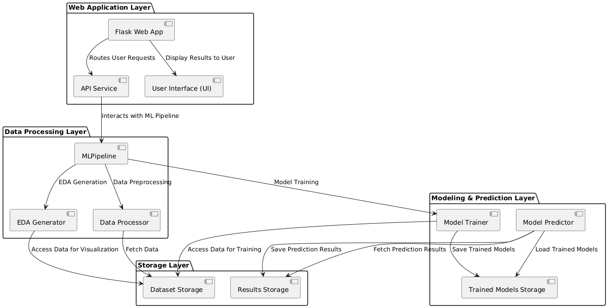
Figure 3.3.1: System Architecture of EduTune
3.3.1 Backend Architecture
The backend architecture provides a clear flow from data ingestion to prediction, ensuring that the process is efficient and user-friendly.

1. Data Ingestion and Preprocessing
This is the first stage of the backend, responsible for loading and preparing the raw dataset for training and prediction.
- Data Input: The data is ingested from a CSV file via the Flask API or through user-uploaded data via the web interface. The dataset is initially stored in a temporary location.
- Preprocessing Steps:
  - Handling Missing Data: Missing values are identified and filled with mean or median values, or dropped based on a predefined threshold (e.g., if more than 30% of the column data is missing).
  - Categorical Encoding: Categorical variables are transformed into numerical data using Label Encoding or One-Hot Encoding, depending on the feature type.
  - Feature Selection: The features and target variables (engagement and performance scores) are separated, and feature scaling (e.g., StandardScaler or MinMaxScaler) is applied if necessary.
  - Data Split: The data is split into training (70%) and testing (30%) sets using train_test_split from Scikit-learn.

2. Model Training and Evaluation
This stage involves training multiple machine learning models on the preprocessed data and evaluating their performance using different metrics.
- Model Types:
  - K-Nearest Neighbors Regressor (KNN): A distance-based regression model for prediction.
  - Support Vector Regressor (SVR): A regression model based on the support vector machine concept.
  - Decision Tree Regressor: A tree-based model for regression.
  - Hybrid Regressor (Linear + Random Forest): A hybrid model combining Linear Regression and Random Forest to capture both linear and non-linear patterns.
- Model Training: Each model is trained using the fit() method from the Scikit-learn library. Training is done using the training dataset.
- Model Evaluation: After training, each model is tested on the test set, and evaluation metrics are calculated:
  - MAE (Mean Absolute Error)
  - MSE (Mean Squared Error)
  - RMSE (Root Mean Squared Error)
  - R2 Score

3. Model Persistence
Once the model is trained, it’s saved for future use to avoid retraining it every time new data is processed.
- Model Saving: Models are serialized using joblib and stored in the models/ directory on the server. This allows the models to be reloaded without retraining.
- Model Loading: When a user requests predictions, the appropriate model is loaded from the disk into memory to make predictions on the provided dataset.

4. Predictions (Single/Bulk)
This is where the backend handles user requests for predictions, whether for a single data point or a batch of data.
- Single Prediction: The user can input a single data point (e.g., one row of the dataset) via the web interface, and the backend uses the pre-trained model to make a prediction for the engagement or performance score.
- Batch Prediction: If the user uploads a batch of data, the backend processes the data in bulk, applies the trained model, and generates predictions for the entire dataset.
- CSV Output: After processing, the backend generates a CSV file containing the predictions, which is then sent to the user for download.

5. Exploratory Data Analysis (EDA)
EDA is performed to visualize and analyze the dataset before training any model, and the visualizations are generated for the user to view and download.
- EDA Generation: After preprocessing, the backend generates several visualizations:
  - Count Plots for categorical variables.
  - Box Plots to check the distribution and outliers.
  - Violin Plots to compare distributions across categories.
  - Scatter Plots to check correlations between features and targets.
  - Correlation Heatmap to visualize relationships between variables.
- Visualization Storage: All the generated plots are saved as PNG images in the static/ directory, allowing the user to download or view them directly via the web interface.

6. Flask Web Application Interface
The Flask app serves as the user interface for interacting with the backend machine learning pipeline.
- API Routes:
  - /upload: For users to upload the dataset.
  - /train: To trigger model training on the uploaded data and save the model.
  - /predict: For making predictions on either a single input or a batch of data.
  - /eda: To generate and display the EDA visualizations.
  - /download: For downloading the predictions or visualizations.
- File Management: The backend handles file uploads and ensures that any inputted data is processed correctly. After generating results (predictions, plots), it offers these as downloadable files.
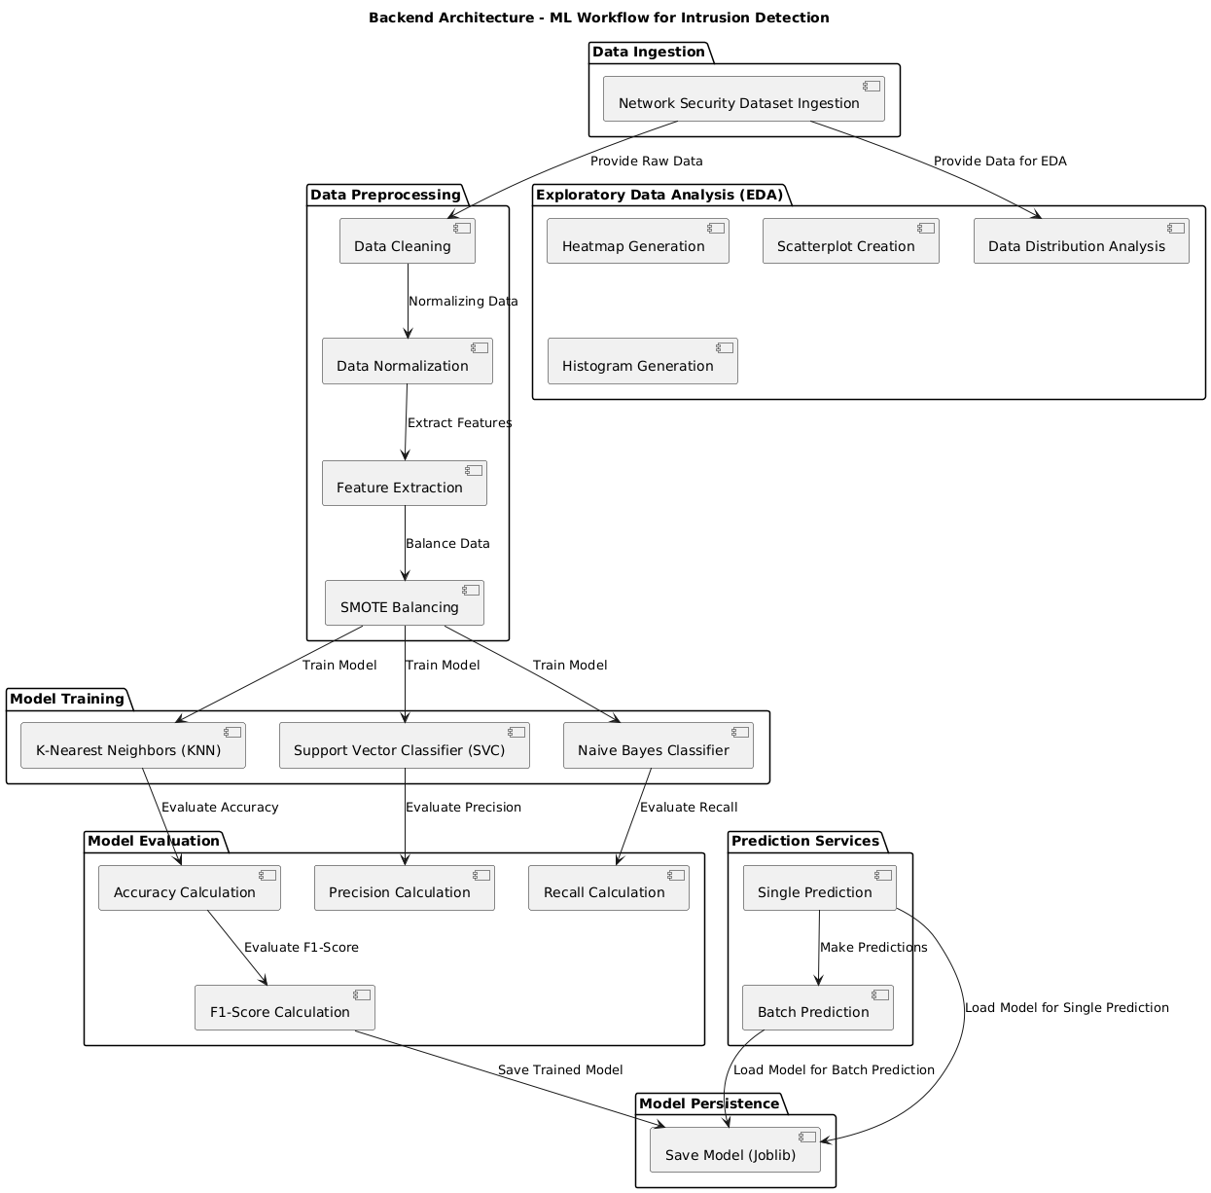
Figure 3.3.1.1 Backend Architecture (ML) of the proposed ensemble approach to predicting engagement and performance in education.

7. Model Reusability & Updates
To maintain efficiency, the backend supports reusing trained models and updating them as needed.
- Model Reuse: If a model already exists, it’s loaded from disk rather than retraining, which ensures faster processing times.
- Model Update: In the future, the backend could support incremental training or model updates if new data is provided, allowing the system to adapt to changing patterns over time.

8. Backend Workflow: High-Level Overview
- Data Ingestion: User uploads dataset → Flask API triggers backend to load and preprocess data.
- EDA Generation: Backend generates EDA plots and returns them to the user.
- Model Training: Model is trained using preprocessed data → Evaluation metrics calculated and saved.
- Model Persistence: Trained model is saved using joblib for future reuse.
- Prediction: User requests predictions (single or batch) → Backend uses the trained model to generate predictions.
- Results: Predictions or visualizations are returned to the user as downloadable files.
3.3.2 Data Preprocessing
Data preprocessing is a crucial step in any machine learning or predictive analytics project. In the context of EDUTUNE, preprocessing ensures that student engagement and performance data is clean, consistent, and ready for modeling. Raw educational data often contains missing values, inconsistent formats, categorical variables, and irrelevant columns, which can degrade model performance if not handled properly. Preprocessing transforms this raw data into a structured and normalized form, enabling the machine learning models—KNN, SVR, DTR, and the Axis Forest ensemble—to learn effectively from the features. Additionally, preprocessing helps in reducing biases, improving model accuracy, and ensuring that the predictions reflect meaningful patterns rather than noise or errors in the data.

Preprocessing Steps (Stepwise)
Step 1: Removing Irrelevant Columns
The first step involves eliminating unnecessary columns such as unnamed indices or identifiers that do not contribute to predictive modeling. For instance, columns automatically generated during CSV exports (e.g., Unnamed: 0) are removed to prevent them from being interpreted as features by the models. This ensures that only relevant features, like heart rate, pitch accuracy, focus time, and engagement level, are used in the analysis.
Step 2: Handling Categorical Data
Many educational datasets contain categorical variables such as class level, engagement type, or participation categories. These need to be converted into numerical representations using techniques like Label Encoding. Label encoding assigns unique integers to each category, enabling models like SVR or Decision Tree to process them efficiently while preserving the distinct classes.
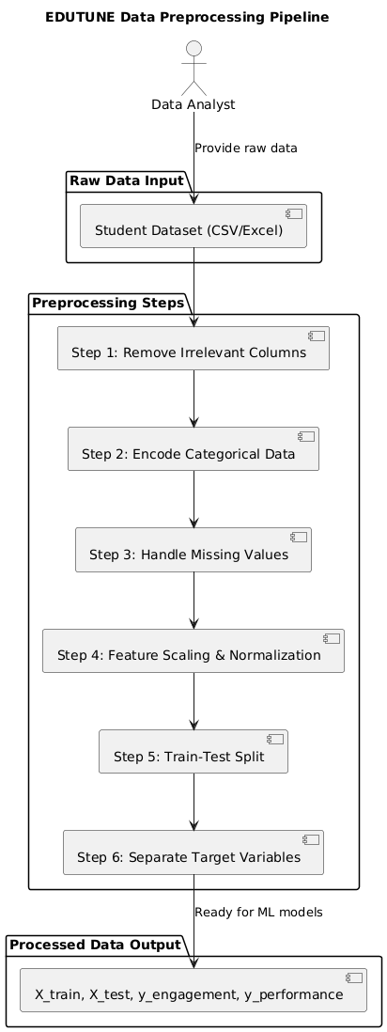
Figure 3.3.2.1 Data Preprocessing of the proposed hybrid ensemble approach to predicting engagement and performance in education.
Step 3: Handling Missing Values
Missing data is common in student datasets due to incomplete records or skipped activities. In EDUTUNE, missing numerical values are replaced with the mean of the corresponding column, ensuring no gaps remain in the dataset. For categorical features, missing values are handled via imputation using the mode or a previously defined encoding strategy. This prevents errors during model training and ensures consistent input data.

Step 4: Feature Scaling and Normalization
Features like focus time, heart rate, and pitch accuracy may have different scales, which can bias models that rely on distance metrics (like KNN) or gradient-based optimization (like SVR). Standardization or Min-Max scaling is applied to bring all features into a comparable range, improving convergence and predictive performance.
Step 5: Splitting Data for Training and Testing
After cleaning and encoding, the dataset is split into training and testing sets. Typically, 80% of the data is used to train the models, while 20% is reserved for evaluating their performance. This ensures that the models are tested on unseen data, providing a realistic measure of predictive accuracy.
Step 6: Label Separation for Target Variables
In EDUTUNE, there are two target variables: Engagement_Score and Performance_Score. These are separated from the feature set to create two dependent variable arrays. The features (independent variables) are then used to predict these scores using the stacked ensemble of models.
3.3.3 Model Building and Training
Model building and training are central to predictive analytics in educational data mining. In EDUTUNE, the goal is to predict student engagement and performance scores based on historical and real-time educational data. Model building involves selecting appropriate machine learning algorithms, feeding them preprocessed data, and optimizing them to minimize prediction errors. During training, the models learn patterns and relationships between input features (such as focus time, heart rate, pitch accuracy, and engagement level) and target variables (Engagement_Score and Performance_Score). Regression models are particularly suitable because the target outputs are continuous numeric scores. Proper model selection, hyperparameter tuning, and evaluation ensure the predictions are accurate, robust, and generalizable to unseen student data. Stacked ensemble methods, like the Axis Forest used in EDUTUNE, combine multiple base models to improve predictive accuracy. This approach leverages the strengths of individual models while compensating for their weaknesses.

3.3.3.1 K-Nearest Neighbors Regressor (KNN)
KNN is a non-parametric, instance-based regression model. It predicts a student’s score by averaging the scores of the 'k' most similar students in the feature space. The similarity is measured using distance metrics like Euclidean distance. KNN is particularly effective in capturing local patterns in student engagement and performance, making it suitable for datasets with clusters or similar behavioral groups.
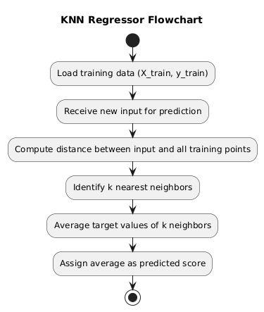
Figure 3.3.3.1 Internal operations workflow of KNN model.
Step 1: Load training features (X_train) and target values (y_train).
Step 2: Compute distance between test point and all training points.
Step 3: Identify the 'k' nearest neighbors based on distance.
Step 4: Average the target values of these neighbors.
Step 5: Assign this average as the predicted score.

3.3.3.2 Support Vector Regressor (SVR)
SVR is a regression adaptation of Support Vector Machines, designed to find a function that deviates from actual target values by a margin (epsilon). It is powerful for modeling non-linear relationships between features and target scores using kernel functions like RBF. SVR provides robust predictions even in high-dimensional or complex educational datasets.
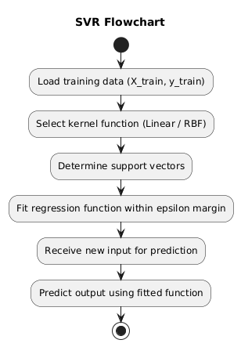
Figure 3.3.3.2 Internal operations workflow of SVM model.
Step 1: Load training data (X_train, y_train).
Step 2: Choose an appropriate kernel (linear, RBF) based on data complexity.
Step 3: Determine support vectors that define the regression function.
Step 4: Fit the regression function to minimize error within epsilon margin.
Step 5: Predict the score for new input features using the fitted function.

3.3.3.3 Decision Tree Regressor (DTR)
DTR predicts scores by recursively splitting the dataset based on feature values to minimize variance in target scores within each leaf. It is highly interpretable, showing how specific feature thresholds influence engagement and performance outcomes. Decision Trees are suitable for capturing non-linear relationships and interactions between educational metrics.

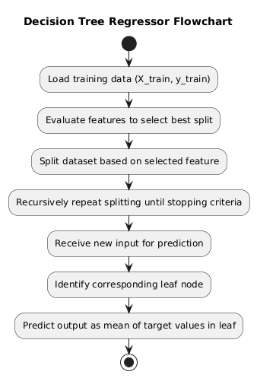
Figure 3.3.3.3 Internal operations workflow of Decision Tree model.
Step 1: Load training data (X_train, y_train).
Step 2: Evaluate all features to select the one that best reduces variance or MSE.
Step 3: Split the dataset into child nodes based on feature thresholds.
Step 4: Recursively repeat splitting until stopping criteria (max depth or min samples) are met.
Step 5: Predict output by taking the mean of target values in the corresponding leaf node.

3.3.3.4 Axis Forest (Hybrid Stacked Ensemble)
The Axis Forest model is a stacked ensemble that combines a base Linear Regression model with a Random Forest meta-model. The base model captures linear patterns, while the meta-model handles residual errors and non-linearities. This hybrid approach improves overall predictive accuracy and generalization for engagement and performance scores across diverse students.
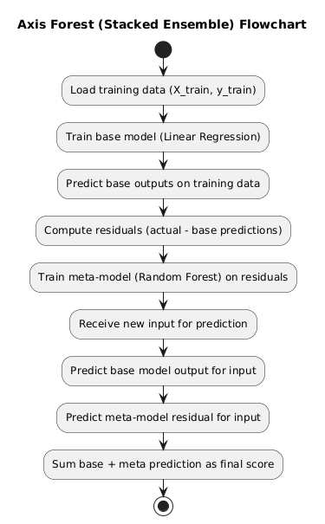
Fig. 3.3.3.4 Axis Forest (Stacked Ensemble) model.
Step 1: Train base Linear Regression model on training data.
Step 2: Predict outputs of base model for the same training data.
Step 3: Compute residuals between actual and base model predictions.
Step 4: Train Random Forest meta-model on residuals.
Step 5: For new inputs, predict final score by summing base model prediction + meta-model prediction.

3.4 Data Flow Diagram (DFD)
The Data Flow Diagram (DFD) represents how data moves through the EDUTUNE system, from user input to final prediction output. It illustrates the interaction between different layers such as the web interface, data processing components, machine learning models, and storage modules. It clearly shows how raw data is transformed into meaningful insights through preprocessing, analysis, and prediction stages. The diagram also highlights the efficient flow of information between components, ensuring accurate results and smooth system operation.
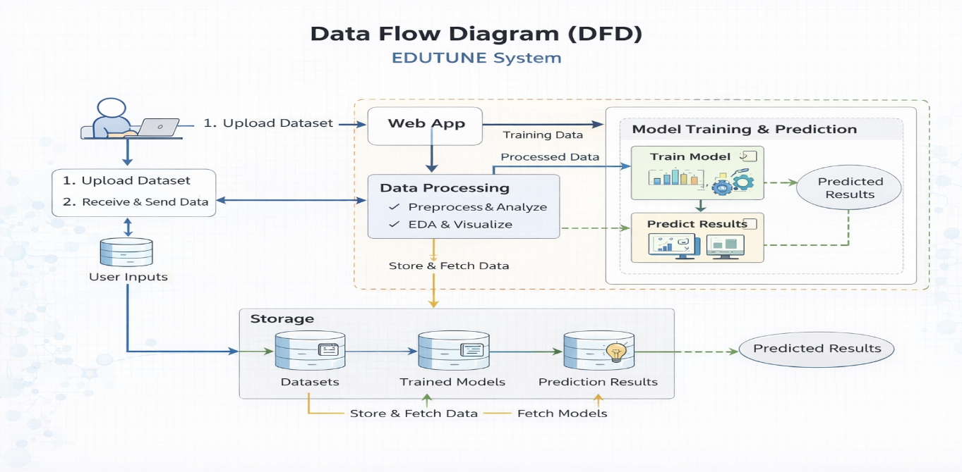
Figure 3.4.1 Data Flow Diagram of Edutune System
3.5 UML Diagrams
Unified Modeling Language (UML) is a standardized visual language used to model, design, and document the architecture of software systems. It provides a set of graphical notations to represent the structure and behavior of a system, making complex systems easier to understand and communicate among developers, stakeholders, and business analysts. To ensure clarity and structured design, the system is modelled using the six essential UML diagrams:
3.5.1 Use Case Diagram
The use case diagram is a behavioral UML diagram that captures the system's functionality from the user's perspective, identifying actors and their interactions with the system. It provides a high-level overview of what the system does, without delving into implementation details. This diagram is useful for stakeholders to validate requirements and ensure all key scenarios are covered. In this application, it focuses on user interactions like uploading data and generating predictions.
K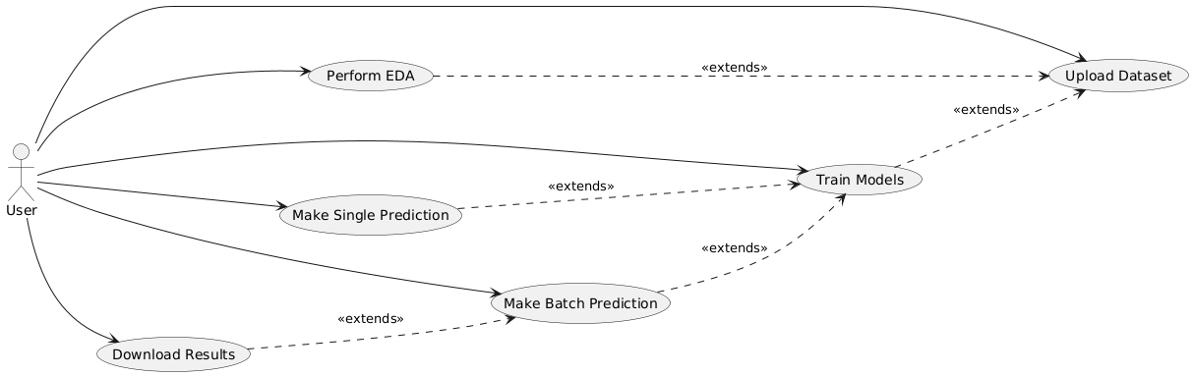
Figure 3.5.1.1 Use Case Diagram
3.5.2 Class Diagram
The class diagram is a structural UML diagram that represents the static view of the system, illustrating classes, their attributes, methods, and relationships. It is essential for understanding the core entities in the software, such as the MLPipeline class and its interactions with external libraries. This diagram helps developers visualize the blueprint of the application, ensuring modular design and ease of maintenance. In this context, it focuses on the MLPipeline class, which encapsulates data processing and machine learning logic, integrated with the Flask application.
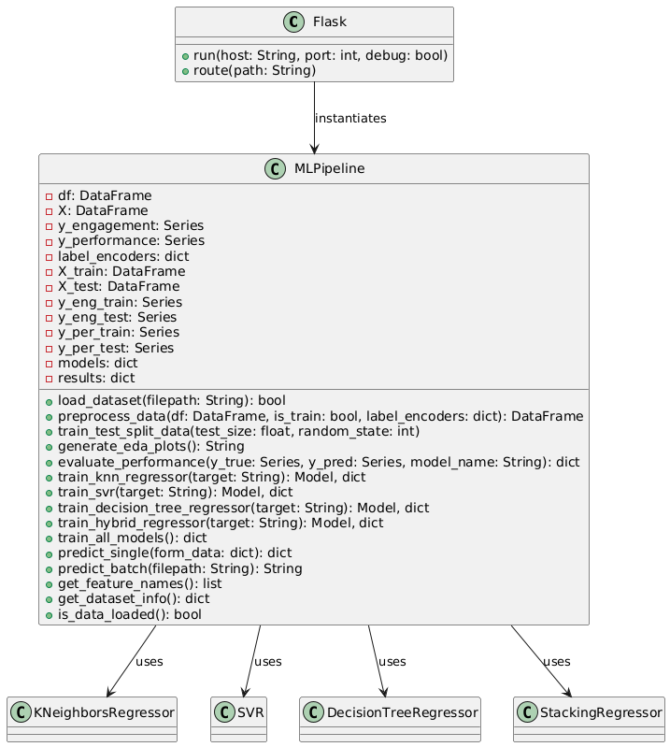
Figure 3.5.2.1 Class Diagram
3.5.3 Activity Diagram
The activity diagram is a behavioral UML diagram that models the workflow of business processes or system operations, focusing on the flow of control and data. It is effective for illustrating sequential and parallel activities. This diagram aids in process optimization and error identification. In this system, it depicts the end-to-end workflow from data upload to results.
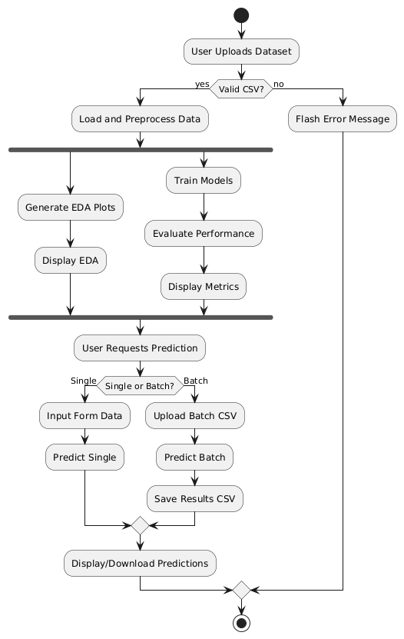
Figure 3.5.3.1 Activity Diagram
3.5.4 Sequence Diagram
The sequence diagram is a behavioral UML diagram that models the dynamic interactions between objects over time, focusing on the order of messages exchanged. It is particularly useful for visualizing scenarios like data processing flows. This diagram helps in debugging and optimizing interactions in the system. Here, it represents a typical workflow from dataset upload to prediction.

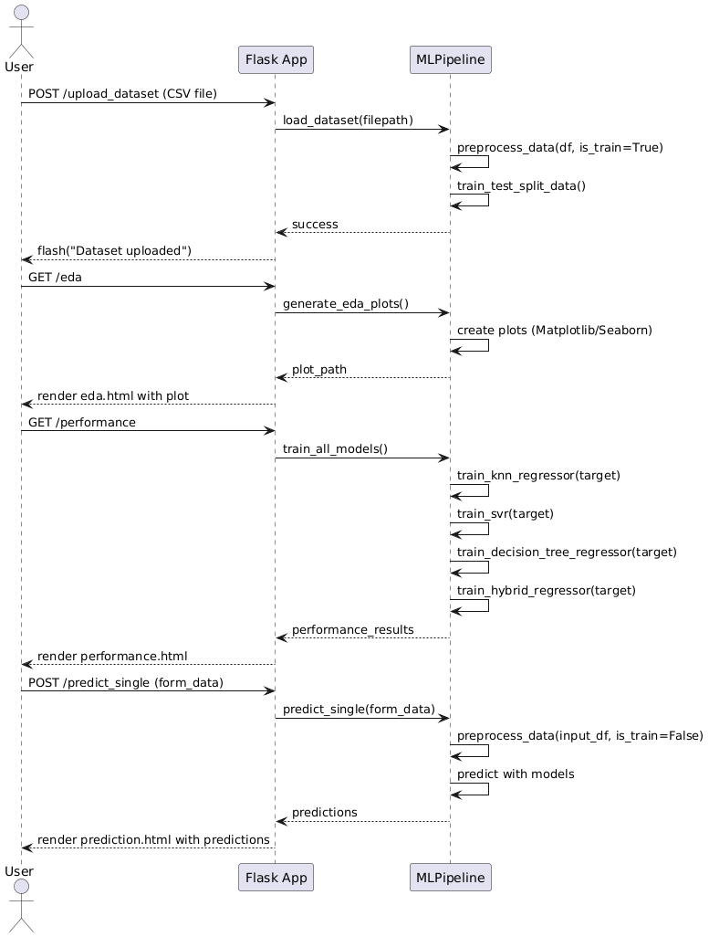
Figure 3.5.4.1 Sequence Diagram
3.5.5 Deployment Diagram
The deployment diagram is a structural UML diagram that models the physical deployment of artifacts on nodes, showing hardware and software configurations. It is crucial for planning infrastructure and ensuring system portability. This diagram helps in identifying deployment constraints and scalability needs. Here, it represents a simple web application deployment.

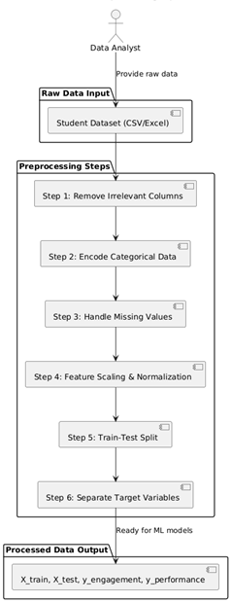
Figure 3.5.5.1 Deployment Diagram
3.5.6 Component Diagram
The component diagram is a structural UML diagram that shows the high-level components of the system and their dependencies, abstracting away implementation details. It is useful for understanding the modular architecture and interfaces. This diagram aids in deployment planning and reusability assessment. In this system, it emphasizes components like the web interface and ML pipeline.

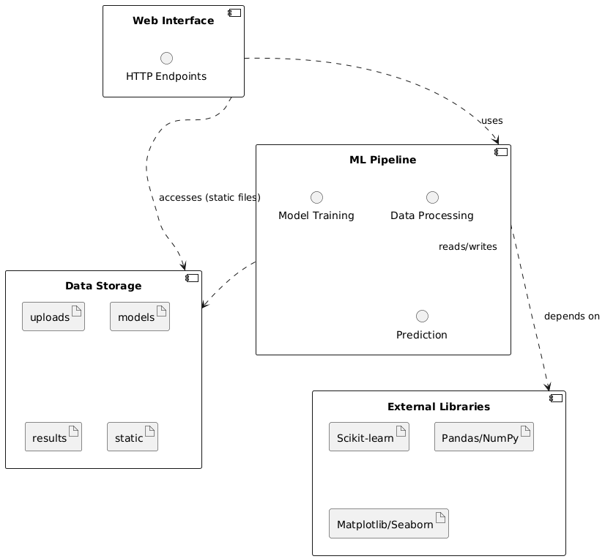
Figure 3.5.6.1 Component Diagram
3.6 Database Design / ER Diagram
The proposed system database is designed to store student datasets, processed data, trained models, and prediction results. The ER diagram represents the relationships between key entities such as the dataset, features, model, and prediction output. This design helps in efficiently managing educational data, supporting model training, and generating accurate predictions. It also enables easy retrieval of stored datasets and results for further analysis and reuse.
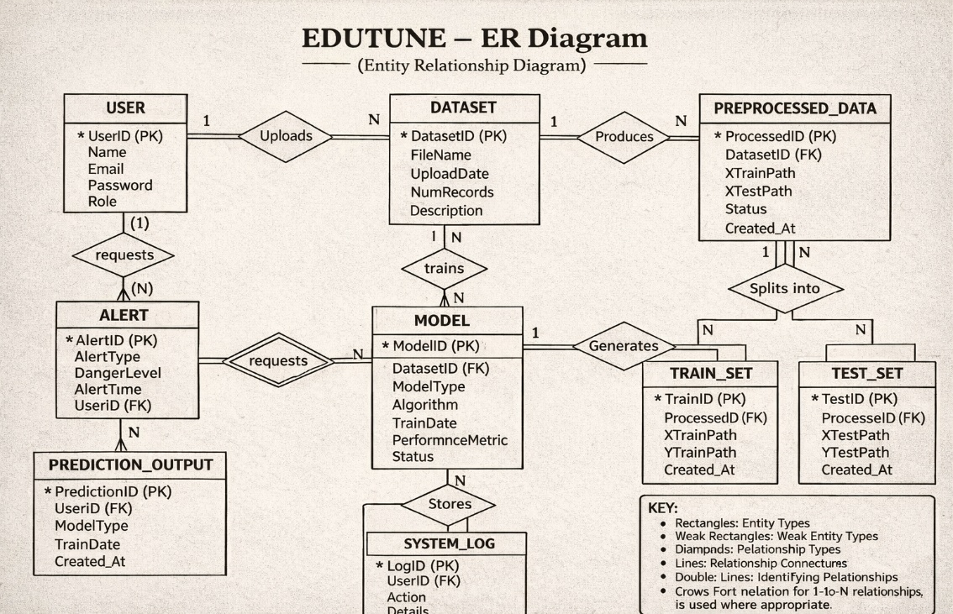
Figure 3.6.1 ER Diagram of Edutune
CHAPTER 4
IMPLEMENTATION
4.1 Tools and Technologies Used
The EDUTUNE project uses a combination of machine learning, data processing, and web development technologies to analyze and predict student engagement and performance efficiently.
Core Technologies
- Machine Learning Algorithms - KNN, SVR, Decision Tree, and Stacking Regressor for prediction
- Python - Main programming language used for development
- Scikit-learn - For implementing machine learning models
- Pandas & NumPy - For data handling and numerical computations
- Matplotlib & Seaborn - For data visualization and EDA
Web Development
- Flask - Used to build the web application and user interface
- HTML, CSS - For designing the front-end interface
Data Processing
- Data Preprocessing Techniques - Handling missing values, encoding, normalization
- EDA (Exploratory Data Analysis) - Used for analyzing patterns and relationships in data
Development Tools
- Jupyter Notebook / Google Colab - For model development and testing
- VS Code / PyCharm - For application development
Storage and Model Handling
- CSV Files - Used for dataset storage and input
- Joblib / Pickle - For saving and loading trained models

4.2 Module Description
The EDUTUNE system is divided into several main modules that work together to analyze student data and predict engagement and performance efficiently.
- Data Input Module
This module allows users to upload student datasets in CSV format through the web interface. It acts as the entry point of the system and provides raw data for further processing.
- Data Preprocessing Module
This module cleans and prepares the dataset by handling missing values, encoding categorical data, and normalizing features. It ensures that the data is in a suitable format for machine learning models.
- Exploratory Data Analysis (EDA) Module
This module generates visualizations such as graphs and heatmaps to understand patterns and relationships in the data. It helps users gain insights before model training.
- Model Training Module
This module trains multiple machine learning models, such as KNN, SVR, and Decision Tree using the processed dataset. It evaluates model performance using metrics like MAE, MSE, RMSE, and R² score.
- Stacked Ensemble Module
This module combines predictions from multiple models using a stacking regressor. It improves overall prediction accuracy and reliability compared to individual models.
- Prediction Module
This module provides both single and batch prediction functionalities. It takes user input or dataset files and generates predictions for student engagement and performance.
- Visualization & Output Module
This module displays results, performance metrics, and predictions through the web interface. It also allows users to download results for further analysis.
- Deployment Module
This module integrates all components into a Flask web application, enabling smooth data processing, model training, and prediction with a user-friendly interface.

4.3 Algorithm / Methodology
The proposed methodology uses a machine learning-based prediction pipeline that analyzes student data and predicts engagement and academic performance using a stacked ensemble approach. The system processes uploaded datasets, performs preprocessing and exploratory data analysis (EDA), trains multiple machine learning models, and combines their outputs to generate accurate predictions.
Algorithm Steps
- Upload the student dataset in CSV format.
- Preprocess data by handling missing values and encoding categorical features.
- Perform feature scaling and normalization.
- Split the dataset into training and testing sets.
- Train individual models (KNN, SVR, Decision Tree).
- Evaluate model performance using metrics (MAE, MSE, RMSE, R²).
- Apply a stacking regressor to combine model predictions.
- Generate predictions for single or batch inputs.
- Display results through the web interface and store outputs.
Methodology Description
The methodology is based on combining multiple machine learning models to improve prediction accuracy. Individual models capture different patterns in the data, while the stacking approach integrates their outputs to produce more reliable results. Data preprocessing and EDA help in understanding the dataset and improving model performance. This structured pipeline ensures efficient and accurate prediction of student engagement and performance.
Stacking Logic
The final prediction is generated by combining outputs from multiple models:
- KNN – Captures local data patterns
- SVR – Handles complex relationships
- Decision Tree – Provides interpretability
- Stacking Regressor – Combines all model predictions for improved accuracy

Deployment Method
After training, the models are integrated into a Flask-based web application. The system performs data processing, model execution, and prediction locally on the server without requiring cloud dependency. This ensures faster response, scalability, and ease of access for users.
4.4 System Implementation
The EDUTUNE system is implemented as a web-based machine learning application using Flask. It allows users to upload datasets, perform data analysis, train models, and generate predictions for student engagement and performance. The system processes data efficiently and provides results through an interactive web interface.
Implementation Flow
- Initialize system: Set up Flask application and required libraries.
- Upload dataset: User uploads CSV file through the web interface.
- Load data: The dataset is loaded into the MLPipeline for processing.
- Preprocess data: Handle missing values and encode categorical features.
- Generate EDA: Create visualizations to analyze data patterns.
- Train models: Apply KNN, SVR, Decision Tree, and Stacking Regressor.
- Evaluate models: Calculate performance metrics (MAE, MSE, RMSE, R²).
- Generate predictions: Perform single or batch predictions.
- Display results: Show outputs and allow download through the interface.
Deployment Details
The system runs on a local server using Flask, enabling efficient data processing and prediction without requiring cloud dependency. It is low-cost, easy to deploy, and suitable for educational institutions and researchers.

CHAPTER 5
SOURCE CODE
import os
import logging
from flask import Flask, render_template, request, redirect, url_for, flash, send_file, jsonify
from werkzeug.utils import secure_filename
import pandas as pd
import numpy as np
from ml_pipeline import MLPipeline
import matplotlib
matplotlib.use('Agg') # Use non-interactive backend
import matplotlib.pyplot as plt
import seaborn as sns

# Configure logging
logging.basicConfig(level=logging.DEBUG)

app = Flask(__name__)
app.secret_key = os.environ.get("SESSION_SECRET", "default_secret_key_for_development")

# Configuration
UPLOAD_FOLDER = 'uploads'
RESULTS_FOLDER = 'results'
MODELS_FOLDER = 'models'
ALLOWED_EXTENSIONS = {'csv'}

# Create directories if they don't exist
for folder in [UPLOAD_FOLDER, RESULTS_FOLDER, MODELS_FOLDER]:
os.makedirs(folder, exist_ok=True)

app.config['UPLOAD_FOLDER'] = UPLOAD_FOLDER
app.config['MAX_CONTENT_LENGTH'] = 16 * 1024 * 1024 # 16MB max file size

# Initialize ML Pipeline
ml_pipeline = MLPipeline()

def allowed_file(filename):
return '.' in filename and filename.rsplit('.', 1)[1].lower() in ALLOWED_EXTENSIONS

@app.route('/')
def home():
return render_template('home.html')

@app.route('/eda')
def eda():
try:
# Check if dataset is loaded
if not ml_pipeline.is_data_loaded():
flash('Please upload a dataset first.', 'warning')
return redirect(url_for('home'))

# Generate EDA plots
plot_path = ml_pipeline.generate_eda_plots()

# Get basic dataset info
dataset_info = ml_pipeline.get_dataset_info()

return render_template('eda.html',
plot_path=plot_path.replace('static/', ''),
dataset_info=dataset_info)
except Exception as e:
flash(f'Error generating EDA: {str(e)}', 'danger')
return redirect(url_for('home'))

@app.route('/performance')
def performance():
try:
# Check if dataset is loaded
if not ml_pipeline.is_data_loaded():
flash('Please upload a dataset first.', 'warning')
return redirect(url_for('home'))

# Train all models and get performance metrics
performance_results = ml_pipeline.train_all_models()

return render_template('performance.html',
results=performance_results)
except Exception as e:
flash(f'Error training models: {str(e)}', 'danger')
return redirect(url_for('home'))

@app.route('/prediction')
def prediction():
# Get feature names for the form
feature_names = ml_pipeline.get_feature_names()
return render_template('prediction.html', feature_names=feature_names)

@app.route('/upload_dataset', methods=['POST'])
def upload_dataset():
if 'dataset' not in request.files:
flash('No file selected', 'danger')
return redirect(url_for('home'))

file = request.files['dataset']
if file.filename == '':
flash('No file selected', 'danger')
return redirect(url_for('home'))

if file and file.filename and allowed_file(file.filename):
filename = secure_filename(file.filename)
filepath = os.path.join(app.config['UPLOAD_FOLDER'], filename)
file.save(filepath)

try:
# Load dataset into ML pipeline
ml_pipeline.load_dataset(filepath)
flash('Dataset uploaded and loaded successfully!', 'success')
except Exception as e:
flash(f'Error loading dataset: {str(e)}', 'danger')
else:
flash('Invalid file format. Please upload a CSV file.', 'danger')

return redirect(url_for('home'))

@app.route('/predict_single', methods=['POST'])
def predict_single():
try:
# Get form data
form_data = {}
feature_names = ml_pipeline.get_feature_names()

for feature in feature_names:
value = request.form.get(feature)
if value is None or value == '':
flash(f'Please provide a value for {feature}', 'danger')
return redirect(url_for('prediction'))
try:
form_data[feature] = float(value)
except ValueError:
# Handle categorical features
form_data[feature] = value

# Make prediction
predictions = ml_pipeline.predict_single(form_data)

flash('Prediction completed successfully!', 'success')
return render_template('prediction.html',
feature_names=feature_names,
predictions=predictions,
input_data=form_data)

except Exception as e:
flash(f'Error making prediction: {str(e)}', 'danger')
return redirect(url_for('prediction'))

@app.route('/predict_batch', methods=['POST'])
def predict_batch():
if 'batch_file' not in request.files:
flash('No file selected', 'danger')
return redirect(url_for('prediction'))

file = request.files['batch_file']
if file.filename == '':
flash('No file selected', 'danger')
return redirect(url_for('prediction'))

if file and file.filename and allowed_file(file.filename):
filename = secure_filename(file.filename)
filepath = os.path.join(app.config['UPLOAD_FOLDER'], filename)
file.save(filepath)

try:
# Make batch predictions
results_path = ml_pipeline.predict_batch(filepath)
flash('Batch prediction completed successfully!', 'success')
return send_file(results_path, as_attachment=True,
download_name='batch_predictions.csv')
except Exception as e:
flash(f'Error making batch prediction: {str(e)}', 'danger')
else:
flash('Invalid file format. Please upload a CSV file.', 'danger')

return redirect(url_for('prediction'))

@app.route('/download_results/<filename>')
def download_results(filename):
try:
filepath = os.path.join(RESULTS_FOLDER, filename)
return send_file(filepath, as_attachment=True)
except Exception as e:
flash(f'Error downloading file: {str(e)}', 'danger')
return redirect(url_for('home'))

if __name__ == '__main__':
app.run(host='0.0.0.0', port=5000, debug=True)
from app import app

if __name__ == '__main__':
app.run(host='0.0.0.0', port=5000, debug=True)
import os
import numpy as np
import pandas as pd
import matplotlib.pyplot as plt
import seaborn as sns
from sklearn.model_selection import train_test_split
from sklearn.preprocessing import LabelEncoder, StandardScaler
from sklearn.neighbors import KNeighborsRegressor
from sklearn.svm import SVR
from sklearn.tree import DecisionTreeRegressor
from sklearn.linear_model import LinearRegression
from sklearn.ensemble import RandomForestRegressor, StackingRegressor
from sklearn.metrics import mean_absolute_error, mean_squared_error, r2_score
import joblib
from joblib import dump, load
import logging

class MLPipeline:
def __init__(self):
self.df = None
self.X = None
self.y_engagement = None
self.y_performance = None
self.label_encoders = None
self.X_train = None
self.X_test = None
self.y_eng_train = None
self.y_eng_test = None
self.y_per_train = None
self.y_per_test = None
self.models = {}
self.results = {}

# Create directories
self.MODEL_DIR = 'models'
self.RESULTS_DIR = 'results'
self.STATIC_DIR = 'static'

for directory in [self.MODEL_DIR, self.RESULTS_DIR, self.STATIC_DIR]:
os.makedirs(directory, exist_ok=True)

def load_dataset(self, filepath):
"""Load dataset from CSV file."""
try:
self.df = pd.read_csv(filepath)
logging.info(f"Dataset loaded successfully with shape: {self.df.shape}")

# Preprocess the data
self.X, self.y_engagement, self.y_performance, self.label_encoders = self.preprocess_data(
self.df.copy(), is_train=True
)

# Split the data
self.train_test_split_data()

return True
except Exception as e:
logging.error(f"Error loading dataset: {str(e)}")
raise e

def preprocess_data(self, df, is_train=True, label_encoders=None):
"""Preprocess the data exactly as in the original code."""
# Drop unnamed columns
df = df.loc[:, ~df.columns.str.contains('^Unnamed')]

if is_train:
label_encoders = {}

# Encode categorical variables
for col in df.select_dtypes(include='object').columns:
le = LabelEncoder()
df[col] = le.fit_transform(df[col].astype(str))
label_encoders[col] = le
else:
if label_encoders is None:
raise ValueError("label_encoders must be provided for test/inference.")

for col in df.select_dtypes(include='object').columns:
if col in label_encoders:
le = label_encoders[col]
df[col] = le.transform(df[col].astype(str))
else:
raise ValueError(f"Missing encoder for column: {col}")

# Fill missing values
df = df.fillna(df.mean(numeric_only=True))

if is_train:
# Extract features and targets
if 'Engagement_Score' in df.columns and 'Performance_Score' in df.columns:
X = df.drop(columns=['Engagement_Score', 'Performance_Score'])
y = df['Engagement_Score']
y1 = df['Performance_Score']
return X, y, y1, label_encoders
else:
# For test data without target columns
return df, None, None, label_encoders
else:
return df

def train_test_split_data(self, test_size=0.2, random_state=42):
"""Split data into train and test sets."""
self.X_train, self.X_test, self.y_eng_train, self.y_eng_test, self.y_per_train, self.y_per_test = train_test_split(
self.X, self.y_engagement, self.y_performance,
test_size=test_size, random_state=random_state
)

def generate_eda_plots(self):
"""Generate EDA plots exactly as in the original code."""
if self.df is None:
raise ValueError("No dataset loaded")

plt.style.use('default')
plt.figure(figsize=(18, 12))

# 1. Count Plot: Class_Level distribution
plt.subplot(2, 3, 1)
if self.X is not None:
sns.countplot(x=self.X['Class_Level'])
else:
raise ValueError("Data not loaded")
plt.title("Distribution of Class Levels")
plt.xlabel("Class Level")
plt.ylabel("Count")

# 2. Box Plot: Heart Rate vs Performance Score
plt.subplot(2, 3, 2)
if self.X is not None and self.y_performance is not None:
sns.boxplot(x=pd.cut(self.X['Heart_Rate (BPM)'], bins=5), y=self.y_performance)
else:
raise ValueError("Data not loaded")
plt.title("Performance Score vs Heart Rate")
plt.xlabel("Heart Rate Range")
plt.ylabel("Performance Score")
plt.xticks(rotation=45)

# 3. Violin Plot: Engagement Level vs Engagement Score
plt.subplot(2, 3, 3)
if self.X is not None and self.y_engagement is not None:
sns.violinplot(x=self.X['Engagement_Level'], y=self.y_engagement)
else:
raise ValueError("Data not loaded")
plt.title("Engagement Score by Engagement Level")
plt.xlabel("Engagement Level (1–10)")
plt.ylabel("Engagement Score")

# 4. Box Plot: Pitch Accuracy vs Performance Score
plt.subplot(2, 3, 4)
if self.X is not None and self.y_performance is not None:
sns.boxplot(x=pd.cut(self.X['Pitch_Accuracy'], bins=5), y=self.y_performance)
else:
raise ValueError("Data not loaded")
plt.title("Performance Score vs Pitch Accuracy")
plt.xlabel("Pitch Accuracy Range")
plt.ylabel("Performance Score")
plt.xticks(rotation=45)

# 5. Scatter Plot: Focus Time vs Engagement Score
plt.subplot(2, 3, 5)
if self.X is not None and self.y_engagement is not None:
sns.scatterplot(x=self.X['Focus_Time (min)'], y=self.y_engagement)
else:
raise ValueError("Data not loaded")
plt.title("Engagement Score vs Focus Time")
plt.xlabel("Focus Time (minutes)")
plt.ylabel("Engagement Score")

# 6. Correlation Heatmap
plt.subplot(2, 3, 6)
if self.X is not None and self.y_engagement is not None and self.y_performance is not None:
corr_df = self.X.copy()
corr_df['Engagement_Score'] = self.y_engagement
corr_df['Performance_Score'] = self.y_performance
else:
raise ValueError("Data not properly loaded")
sns.heatmap(corr_df.corr(), annot=False, cmap='coolwarm', center=0)
plt.title("Correlation Heatmap")

plt.tight_layout()

# Save plot
plot_path = os.path.join(self.STATIC_DIR, 'eda_plots.png')
plt.savefig(plot_path, dpi=300, bbox_inches='tight')
plt.close()

return plot_path

def evaluate_performance(self, y_true, y_pred, model_name):
"""Evaluate model performance."""
mae = mean_absolute_error(y_true, y_pred)
mse = mean_squared_error(y_true, y_pred)
rmse = np.sqrt(mse)
r2 = r2_score(y_true, y_pred)

return {'MAE': mae, 'MSE': mse, 'RMSE': rmse, 'R2_Score': r2}

def train_knn_regressor(self, target='engagement'):
"""Train KNN Regressor."""
model_name = f'knn_regressor_{target}.joblib'
model_path = os.path.join(self.MODEL_DIR, model_name)

# Select target
if target == 'engagement':
y_train, y_test = self.y_eng_train, self.y_eng_test
else:
y_train, y_test = self.y_per_train, self.y_per_test

if os.path.exists(model_path):
model = load(model_path)
logging.info(f"Loaded existing KNN Regressor for {target}")
else:
model = KNeighborsRegressor(n_neighbors=5)
model.fit(self.X_train, y_train)
dump(model, model_path)
logging.info(f"Trained and saved new KNN Regressor for {target}")

y_pred = model.predict(self.X_test)
performance = self.evaluate_performance(y_test, y_pred, f"KNN_{target}")

return model, performance

def train_svr(self, target='engagement'):
"""Train SVR."""
model_name = f'svr_{target}.joblib'
model_path = os.path.join(self.MODEL_DIR, model_name)

# Select target
if target == 'engagement':
y_train, y_test = self.y_eng_train, self.y_eng_test
else:
y_train, y_test = self.y_per_train, self.y_per_test

if os.path.exists(model_path):
model = load(model_path)
logging.info(f"Loaded existing SVR for {target}")
else:
model = SVR(kernel='rbf')
model.fit(self.X_train, y_train)
dump(model, model_path)
logging.info(f"Trained and saved new SVR for {target}")

y_pred = model.predict(self.X_test)
performance = self.evaluate_performance(y_test, y_pred, f"SVR_{target}")

return model, performance

def train_decision_tree_regressor(self, target='engagement'):
"""Train Decision Tree Regressor."""
model_name = f'decision_tree_regressor_{target}.joblib'
model_path = os.path.join(self.MODEL_DIR, model_name)

# Select target
if target == 'engagement':
y_train, y_test = self.y_eng_train, self.y_eng_test
else:
y_train, y_test = self.y_per_train, self.y_per_test

if os.path.exists(model_path):
model = load(model_path)
logging.info(f"Loaded existing Decision Tree Regressor for {target}")
else:
model = DecisionTreeRegressor(max_depth=2, random_state=42)
model.fit(self.X_train, y_train)
dump(model, model_path)
logging.info(f"Trained and saved new Decision Tree Regressor for {target}")

y_pred = model.predict(self.X_test)
performance = self.evaluate_performance(y_test, y_pred, f"DecisionTree_{target}")

return model, performance

def train_hybrid_regressor(self, target='engagement'):
"""Train hybrid model: Linear Regression (base) + Random Forest (meta)."""
model_name = f'hybrid_regressor_{target}.joblib'
model_path = os.path.join(self.MODEL_DIR, model_name)

# Select target
if target == 'engagement':
y_train, y_test = self.y_eng_train, self.y_eng_test
else:
y_train, y_test = self.y_per_train, self.y_per_test

if os.path.exists(model_path):
model = load(model_path)
logging.info(f"Loaded existing Hybrid Regressor for {target}")
else:
base_model = LinearRegression()
meta_model = RandomForestRegressor(n_estimators=100, random_state=42)

model = StackingRegressor(
estimators=[('lr', base_model)],
final_estimator=meta_model,
passthrough=True
)
model.fit(self.X_train, y_train)
dump(model, model_path)
logging.info(f"Trained and saved new Hybrid Regressor for {target}")

y_pred = model.predict(self.X_test)
performance = self.evaluate_performance(y_test, y_pred, f"Hybrid_{target}")

return model, performance

def train_all_models(self):
"""Train all models for both targets."""
results = {}

for target in ['engagement', 'performance']:
target_results = {}

# Train KNN
model, perf = self.train_knn_regressor(target)
self.models[f'knn_{target}'] = model
target_results['KNN'] = perf

# Train SVR
model, perf = self.train_svr(target)
self.models[f'svr_{target}'] = model
target_results['SVR'] = perf

# Train Decision Tree
model, perf = self.train_decision_tree_regressor(target)
self.models[f'dt_{target}'] = model
target_results['Decision Tree'] = perf

# Train Hybrid
model, perf = self.train_hybrid_regressor(target)
self.models[f'hybrid_{target}'] = model
target_results['Hybrid'] = perf

results[target] = target_results

self.results = results
return results

def predict_single(self, form_data):
"""Make prediction on single input."""
# Convert form data to DataFrame
input_df = pd.DataFrame([form_data])

# Preprocess the input
processed_input = self.preprocess_data(input_df, is_train=False, label_encoders=self.label_encoders)

predictions = {}

# Make predictions with all models for both targets
for target in ['engagement', 'performance']:
target_predictions = {}

for model_type in ['knn', 'svr', 'dt', 'hybrid']:
model_key = f'{model_type}_{target}'
if model_key in self.models:
pred = self.models[model_key].predict(processed_input)[0]
target_predictions[model_type.upper()] = round(pred, 4)

predictions[target] = target_predictions

return predictions

def predict_batch(self, filepath):
"""Make batch predictions on CSV file."""
# Load test data
test_df = pd.read_csv(filepath)

# Preprocess the data
processed_data = self.preprocess_data(test_df.copy(), is_train=False, label_encoders=self.label_encoders)

# Make predictions
results_df = test_df.copy()

for target in ['engagement', 'performance']:
for model_type in ['knn', 'svr', 'dt', 'hybrid']:
model_key = f'{model_type}_{target}'
if model_key in self.models:
predictions = self.models[model_key].predict(processed_data)
results_df[f'{target}_{model_type}_prediction'] = predictions

# Save results
results_path = os.path.join(self.RESULTS_DIR, 'batch_predictions.csv')
results_df.to_csv(results_path, index=False)

return results_path

def get_feature_names(self):
"""Get feature names for the form."""
if self.X is not None:
return list(self.X.columns)
else:
# Default feature names based on the dataset structure
return [
'Age', 'Gender', 'Class_Level', 'Accuracy (%)', 'Rhythm (%)',
'Tempo (BPM)', 'Pitch_Accuracy', 'Volume (dB)', 'Heart_Rate (BPM)',
'Stress_Level', 'Engagement_Level', 'Focus_Time (min)',
'Behavior_Score', 'Instrument', 'Lesson_Type', 'Skill_Development'
]

def get_dataset_info(self):
"""Get basic dataset information."""
if self.df is not None:
return {
'shape': self.df.shape,
'columns': list(self.df.columns),
'missing_values': self.df.isnull().sum().sum(),
'data_types': self.df.dtypes.to_dict()
}
return None

def is_data_loaded(self):
"""Check if data is loaded."""
return self.df is not None

CHAPTER 6
RESULTS AND DISCUSSION
6.1 System Testing

System testing was performed to verify the complete EDUTUNE system as an integrated unit. The testing focused on dataset upload, data preprocessing, exploratory data analysis (EDA), model training, prediction generation, and result display to ensure that all components worked together correctly.

The system was tested using different datasets and input conditions, including valid datasets, missing values, and batch prediction scenarios. The results showed that the system could successfully process data, generate visualizations, and predict student engagement and performance accurately.

The machine learning models such as KNN, SVR, Decision Tree, and Stacking Regressor performed effectively during testing. The system correctly evaluated model performance using metrics like MAE, MSE, RMSE, and R² score. The preprocessing module ensured clean and structured data, improving prediction accuracy.

The prediction module worked as expected for both single and batch inputs. The system generated accurate predictions and allowed users to download results easily. The Flask web interface displayed EDA plots, model performance, and prediction outputs clearly and in real time.

Overall, system testing confirmed that the EDUTUNE system is functional, reliable, and efficient. The results demonstrate that the system can support data-driven decision-making and improve student engagement and performance analysis.

6.1.1 Test Cases
- Valid dataset condition: System accepts correctly formatted CSV data and processes it successfully.
- Missing data condition: System handles missing values during preprocessing without errors.
- Single prediction condition: System generates accurate output for individual input data.
- Batch prediction condition: System processes multiple records and produces results in CSV format.
- Model training condition: System trains model and displays performance metrics correctly.
- EDA condition: System generates proper visualizations for data analysis.
- Invalid input condition: System shows error messages for incorrect file format or missing inputs.

6.1.2 Observations
- Accurate predictions were achieved using multiple machine learning models.
- Data preprocessing improved the quality and reliability of results.
- Model performance evaluation provided clear insights into accuracy.
- The system handled both single and batch predictions efficiently.
- EDA visualizations helped in a better understanding of data patterns.
- The web interface remained stable during continuous operation.
- Results were generated and displayed without noticeable delay.
6.2 Output Screens

Figure 6.2.1 Frontend Dashboard of EduTune for Engagement and Performance Prediction

The figure illustrates the main dashboard of the EDUTUNE system, which serves as the entry point for users. It provides options to upload datasets and navigate to different modules such as Exploratory Data Analysis (EDA), Model Performance, Single Prediction, and Batch Prediction. The interface is designed with a clean layout and intuitive controls, allowing users to easily interact with the system. It also includes an overview section describing the system features, prediction targets, and supported machine learning models, making it informative for first-time users.


Figure 6.2.2 Exploratory Data Analysis Summary of EduTune.
This figure shows the dataset summary after uploading a CSV file. It displays key information such as the total number of records, the number of features, missing values, and the total number of columns present in the dataset. This section helps users quickly understand the structure and quality of the data before performing further analysis. It is particularly useful for identifying data issues like missing values, which can impact model performance.

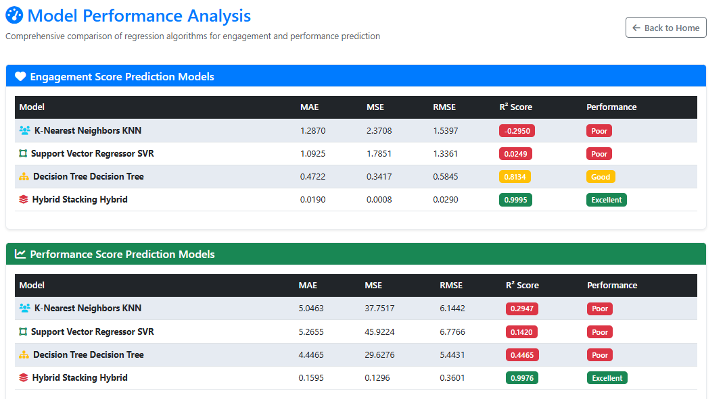
Figure 6.2.3 Model Performance Analysis for Engagement and Performance Prediction.

This figure shows the performance comparison of different machine learning models used in the EDUTUNE system for predicting engagement and performance scores. It displays evaluation metrics such as MAE (Mean Absolute Error), MSE (Mean Squared Error), RMSE (Root Mean Squared Error), and R² Score for models like KNN, SVR, Decision Tree, and Hybrid Stacking. The results clearly indicate that the stacking model achieves the highest accuracy with the lowest error values and the best R² score. This section helps users understand which model performs best and supports selection of the most reliable prediction method.

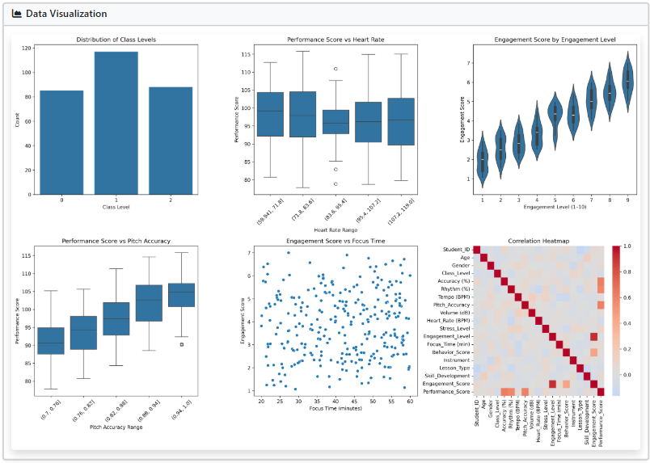
Figure 6.2.4 Data Visualization (EDA Graphs)
The figure presents multiple visualizations generated during exploratory data analysis. These include bar charts, box plots, scatter plots, and correlation heatmaps. Each visualization helps in understanding different aspects of the dataset, such as the distribution of variables, relationships between features, and patterns affecting student engagement and performance. The correlation heatmap, in particular, helps identify strong and weak relationships between variables, aiding in feature selection and model improvement.

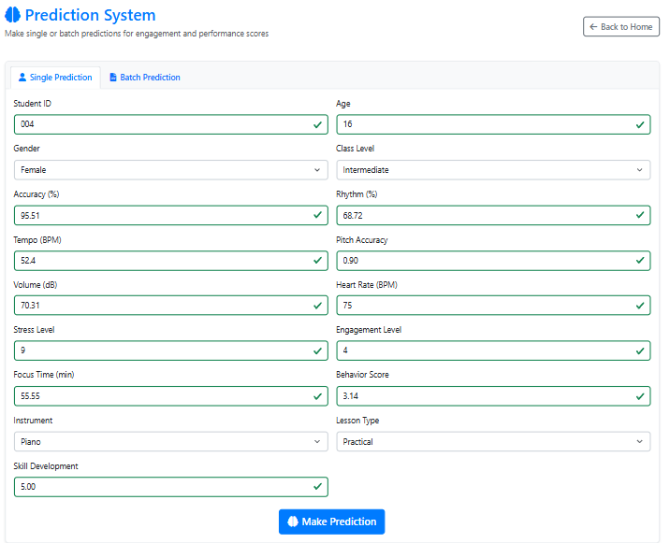
Figure 6.2.5 Prediction Interface for Single Input Analysis.
This figure shows the interface used for generating predictions. Users can enter individual student details such as age, gender, engagement level, accuracy, heart rate, and other performance-related attributes. The system also provides an option for batch prediction by uploading multiple records in CSV format. The input fields are well-structured and validated, ensuring that users provide correct data for accurate predictions.

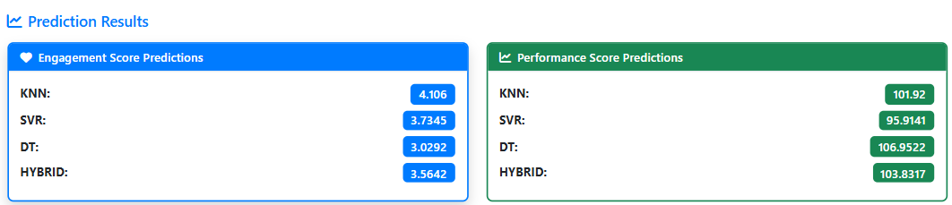
Figure 6.2.6 Prediction of the Test Data.
This figure displays the output generated by the system after prediction. It shows results from multiple machine learning models, including KNN, SVR, Decision Tree, and Stacking (Hybrid model). The output includes both engagement score and performance score predictions, allowing users to compare model outputs. The results are presented clearly in a structured format, making it easy to interpret and analyze the predictions.
6.3 Performance Analysis
The performance of the EDUTUNE system is analyzed based on its ability to accurately predict student engagement and academic performance using machine learning models. The system combines multiple algorithms through a stacked ensemble approach, so its performance depends on both individual model accuracy and the effectiveness of their combination.
The system performed well in processing datasets, generating insights, and producing predictions. In normal conditions, it handled data efficiently without errors, and the preprocessing module ensured clean and structured input. During testing, the system successfully generated predictions for both engagement and performance scores using different models.
A major strength of the system is the use of stacked ensemble learning. By combining models such as KNN, SVR, and Decision Tree, the system achieved better accuracy compared to individual models. The performance metrics clearly show that the hybrid stacking model produced the lowest error values (MAE, MSE, RMSE) and the highest R² score, indicating superior prediction performance.
The prediction and visualization modules also worked effectively. The system provided real-time results through the Flask interface, and users could easily interpret outputs using graphs and performance tables. This improves usability and supports data-driven decision-making. From a practical perspective, the system is efficient, scalable, and easy to deploy on standard computing systems without requiring high-end resources. It does not depend on cloud infrastructure, making it suitable for academic environments and research purposes.
Overall, the performance analysis shows that the EDUTUNE system is accurate, reliable, and efficient in predicting student engagement and performance, with improved results achieved through the stacking approach.
6.4 Advantages of the System
The proposed EDUTUNE system has several important advantages as it combines machine learning, data analysis, and a user-friendly web interface. It is designed to accurately predict student engagement and performance, reduce manual effort, and support data-driven decision-making in educational environments.
Advantages
- It predicts student engagement and performance with high accuracy using multiple machine learning models.
- It works efficiently and provides results quickly without delay.
- It improves prediction reliability by using a stacked ensemble approach instead of a single model.
- It helps in early identification of low-performing or disengaged students.
- It is cost-effective as it uses open-source tools and does not require expensive hardware.
- It does not depend on cloud infrastructure and can run on local systems.
- It supports both single and batch predictions for practical usage.
- It provides clear visualizations through EDA for better data understanding.
- It offers a user-friendly Flask-based web interface for easy interaction.
- It is scalable and can be extended for larger datasets and institutional use.
- It helps educators make better decisions and improve learning outcomes.

CHAPTER 7
CONCLUSION AND FUTURE SCOPE
7.1 Conclusion
The EduTune project, developed using the Flask framework and a custom MLPipeline class, successfully provides a comprehensive platform for predicting student engagement and performance in music education activities. The system allows seamless dataset uploads, performs exploratory data analysis (EDA) with insightful visualizations, and supports multiple regression models, including K-Nearest Neighbors (KNN), Support Vector Regressor (SVR), Decision Tree, and Stacking Regressor. The platform enables both single and batch predictions, as demonstrated through the user-friendly interface. Despite its success, there are opportunities to enhance performance further. Implementing asynchronous processing with Celery could drastically reduce response times, while incorporating feature scaling during data preprocessing would improve model accuracy. Additionally, optimizing file I/O by caching models in memory can significantly improve prediction latency. These performance enhancements, combined with the system's modular architecture, make EduTune an invaluable tool for educators and researchers in the field of music education, with potential for broader adoption and increased efficiency.
7.2 Future Enhancements
In the future, EduTune could integrate a relational database system (e.g., PostgreSQL) to replace the current file-based storage, which would offer better data management and scalability. Additionally, interactive visualizations using Chart.js and the ability to retrain models in real-time could provide a more engaging user experience and lead to more accurate predictions as more data is collected over time. These features would improve the platform's overall functionality and user engagement, positioning it as a leading tool in educational technology.

REFERENCES
- Guo P. J., Kim J., Rubin R. How video production student engagement: an empirical study of MOOC videos. Proceedings of First ACM Conference on Learning @ Scale; March 2014; Atlanta, GA, USA. pp. 41–50. https://pmc.ncbi.nlm.nih.gov/articles/PMC6189675/#ref-list1
- Bonafini F. C., Chae C., Park E., Jablokow K. W. How much does student engagement with videos and forums in a MOOC affect their achievement? Online Learning. 2017;21(4):223–240. doi: 10.24059/olj.v21i4.1270. https://pmc.ncbi.nlm.nih.gov/articles/PMC6189675/#ref-list1
- Ramesh A., Goldwasser D., Huang B., Daum H., Getoor L. Learning latent engagement patterns of students in online courses. Proceedings of Twenty-Eighth AAAI Conference on Artificial Intelligence; July 2014; Québec, Canada. AAAI Press; pp. 1272–1278. https://pmc.ncbi.nlm.nih.gov/articles/PMC6189675/#ref-list1
- Manwaring K. C., Larsen R., Graham C. R., Henrie C. R., Halverson L. R. Investigating student engagement in blended learning settings using experience sampling and structural equation modelling. Internet and Higher Education 2017. https://pmc.ncbi.nlm.nih.gov/articles/PMC6189675/#ref-list1
- Mutahi J., Kinai A., Bore N., Diriye A., Weldemariam K. Studying engagement and performance with learning technology in an African classroom. Proceedings of Seventh International Learning Analytics & Knowledge Conference; March 2017; Vancouver, BC, Canada. pp. 148–152. https://pmc.ncbi.nlm.nih.gov/articles/PMC6189675/#ref-list1
- Aguiar E., Ambrose G. A., Chawla N. V., Goodrich V., Brockman J. Engagement vs performance: using electronic portfolios to predict first semester engineering student persistence. Journal of Learning Analytics. 2014;1(3):7–33. doi: 10.18608/jla.2014.13.3. https://pmc.ncbi.nlm.nih.gov/articles/PMC6189675/#ref-list1
- Thomas C., Jayagopi D. B. Predicting student engagement in classrooms using facial behavioral cues. Proceedings of 1st ACM SIGCHI International Workshop on Multimodal Interaction for Education; November 2017; Glasgow, UK. pp. 33–40. https://pmc.ncbi.nlm.nih.gov/articles/PMC6189675/#ref-list1
- Atherton M., Shah M., Vazquez J., Griffiths Z., Jackson B., Burgess C. Using learning analytics to assess student engagement and academic outcomes in open access enabling programmes. Journal of Open, Distance and e-Learning. 2017;32(2):119–136. doi: 10.1080/02680513.2017.1309646. https://pmc.ncbi.nlm.nih.gov/articles/PMC6189675/#ref-list1
- Ding L., Er E., Orey M. An exploratory study of student engagement in gamified online discussions. Computers & Education. 2018;120:213–226. https://pmc.ncbi.nlm.nih.gov/articles/PMC6189675/#ref-list1
- Wells M., Wollenschlaeger A., Lefevre D., Magoulas G. D., Poulovassilis A. Analysing engagement in an online management programme and implications for course design. Proceedings of Sixth International Conference on Learning Analytics & Knowledge; April 2016; Edinburgh, UK. pp. 236–240. https://pmc.ncbi.nlm.nih.gov/articles/PMC6189675/#ref-list1
- Pardo A., Han F., Ellis R. A. Exploring the relation between self-regulation, online activities, and academic performance: a case study. Proceedings of Sixth International Conference on Learning Analytics & Knowledge; April 2016; Edinburgh, UK. pp. 422–429. https://pmc.ncbi.nlm.nih.gov/articles/PMC6189675/#ref-list1
- Hamid S. S. A., Admodisastro N., Manshor N., Kamaruddin A., Ghani A. A. A. Dyslexia adaptive learning model: student engagement prediction using machine learning approach. In: Ghazali R., Deris M., Nawi N., Abawajy J., editors. Advances in Intelligent Systems and Computing. Berlin, Germany: Springer; 2018. pp. 372–384. https://pmc.ncbi.nlm.nih.gov/articles/PMC6189675/#ref-list1
- Rodgers T. Student engagement in the e-learning process and the impact on their grade. International Journal of Cyber Society and Education. 2008;1(3):143–156. https://pmc.ncbi.nlm.nih.gov/articles/PMC6189675/#ref-list1
- Bote-Lorenzo M. L., Gomez-Sanchez E. Predicting the decrease of engagement indicators in a MOOC. Proceedings of Seventh International Conference on Learning Analytics and Knowledge; March 2017; Vancouver, British Columbia, Canada. pp. 143–147. https://pmc.ncbi.nlm.nih.gov/articles/PMC6189675/#ref-list1
- A.W. Cole, L. Lennon, and N. L. Weber, “Student perceptions of online active learning practices and online learning climate predict online course engagement,” Interact. Learn. Environ., vol. 29, no. 5, pp. 866–880, 2021.https://www.techscience.com/csse/v48n5/57943/html#s2
- L. Ali and N. A. H. H. A. Dmour, “The shift to online assessment due to COVID-19: An empirical study of university students, behaviour and performance, in the region of UAE,” Int. J. Inf. Educ. Technol., vol. 11, no. 5, pp. 220–228, 2021.https://www.techscience.com/csse/v48n5/57943/html#s2
- Y. C. Semerci and D. Goularas, “Evaluation of students’ flow state in an e-learning environment through activity and performance using deep learning techniques,” J. Educ. Comput. Res., vol. 59, no. 5, pp. 960–987, 2020. https://www.techscience.com/csse/v48n5/57943/html#s2
- C. Gray and D. Perkins, “Utilizing early engagement and machine learning to predict student outcomes,” Comput. Edu., vol. 131, pp. 22–32, 2019. https://www.techscience.com/csse/v48n5/57943/html#s2
- C. Lu and M. Cutumisu, “Online engagement and performance on formative assessments mediate the relationship between attendance and course performance,” Int. J. Educ. Technol. High. Educ., vol. 19, no. 1, pp. 2, 2022https://www.techscience.com/csse/v48n5/57943/html#s2
- L. Yang and Z. Bai, “Study on score prediction model with high efficiency based on deep learning,” Electronics, vol. 11, no. 23, pp. 3995, 2022. https://www.techscience.com/csse/v48n5/57943/html#s2
- P. Nayak, , “Predicting students’ academic performance by mining the educational data through machine learning-based classification model,” Educ. Inform. Technol., vol. 28, no. 11, pp. 14611–14637, 2023. https://www.techscience.com/csse/v48n5/57943/html#s2
- Hernández-Blanco et al., 2019 et al.A systematic review of deep learning approaches to educational data mining. https://www.techscience.com/csse/v48n5/57943/html#s2
- Namoun and Alshanqiti, 2021 Predicting student performance using data mining and learning analytics techniques: A systematic literature reviewApplied Sciences (Switzerland), 11 (2021), pp. 1-28. https://www.techscience.com/csse/v48n5/57943/html#s2
- Albreiki et al., 2021 A systematic literature review of student' performance prediction using machine learning techniquesEducation Sciences, 11 (2021). https://www.techscience.com/csse/v48n5/57943/html#s2
- Nawang et al., 2021 A systematic literature review on student performance predictionsInternational Journal of Advanced Technology and Engineering Exploration, 8 (2021), pp. 1441-1453. https://www.techscience.com/csse/v48n5/57943/html#s2
- Baashar et al., 2022 Toward predicting student's academic performance using artificial neural networks (anns) Applied Sciences (Switzerland), 12 (2022). https://www.techscience.com/csse/v48n5/57943/html#s2
- Biggs et al., 2022 Teaching for quality learning at university McGraw-Hill Education (UK) (2022). https://www.sciencedirect.com/science/article/pii/S2666920X24000328#bl0010
- Kotsiantis, S.B.; Pierrakeas, C.; Pintelas, P.E. Predicting students’ performance in distance learning using machine learning techniques. Appl. Artif. Intell. 2004, 18, 411–426. https://www.mdpi.com/2073-8994/12/5/728
- Gong, Yue, Joseph E. Beck, and Neil T. Heffernan. 2011. How to construct more accurate student models: Comparing and optimizing knowledge tracing and performance factor analysis. International Journal of Artificial Intelligence in Education 21: 27–46. https://www.mdpi.com/2079-3200/12/12/124
- Corbett, Albert T., and John R. Anderson. 1994. Knowledge tracing: Modeling the acquisition of procedural knowledge. User Modeling and User-Adapted Interaction 4: 253–78. https://www.mdpi.com/2079-3200/12/12/124
- Hernández, Juan Antonio Caballero, Antonio B. Alberico, Manuel Palomo Duarte, Pablo Dellatorre, Antonio J. Reinoso, and Juan Manuel D. Beardo. 2020. Teamwork assessment in collaborative projects through process mining techniques. The International Journal of Engineering Education 36: 470–82. https://www.mdpi.com/2079-3200/12/12/124
- Pisner, Derek A., and M. Schnyer. 2020. Support vector machine. In Machine Learning. Cambridge: Academic Press, pp. 101–21. https://www.mdpi.com/2079-3200/12/12/124
- Bendangnuksung, Prabu P. 2018. Students’ performance prediction using deep neural network. International Journal of Applied Engineering Research 13: 1171–76. https://www.mdpi.com/2079-3200/12/12/124
- Raihana, Z., and A. M. Farah Nabilah. 2018. Classification of students based on quality of life and academic performance by using support vector machine. Journal of Academia 6: 45–52. https://www.mdpi.com/2079-3200/12/12/124
- Hasan, Raza,. 2018. Student academic performance prediction by using decision tree algorithm. Paper presented at 2018 4th International Conference on Computer and Information Sciences (ICCOINS), Kuala Lumpur, Malaysia, August 13–14; pp. 1–5. https://www.mdpi.com/2079-3200/12/12/124
- Divyabharathi, Y., and P. Someswari. 2018. A Framework for Student Academic Performance Using Naïve Bayes Classification Technique. JAET 6: 1–4. https://www.mdpi.com/2079-3200/12/12/124
- Francis, Bindhia K., and Suvanam Sasidhar Babu. 2019. Predicting academic performance of students using a hybrid data mining approach. Journal of Medical Systems 43: 162. https://www.mdpi.com/2079-3200/12/12/124
- Gütter, Jonas, Anna Kruspe, Xiao Xiang Zhu, and Julia Niebling. 2022. Impact of training set size on the ability of deep neural networks to deal with omission noise. Frontiers in Remote Sensing 3: 932431. https://www.mdpi.com/2079-3200/12/12/124
- Ahmed, Shams Forruque, M. Sakib Bin Alam, Maruf Hassan, Mahtabin Rodela Rozbu, Taoseef Ishtiak, Nazifa Rafa, M. Mofijur, A. B. M. Shawkat Ali, and Amir H. Gandomi. 2023. Deep learning modelling techniques: Current progress, applications, advantages, and challenges. Artificial Intelligence Review 56: 13521–617. https://www.mdpi.com/2079-3200/12/12/124
- Zorić, Alisa Bilal. 2019. Predicting Students’ Success Using Neural Network. Paper presented at 2019 ENTRENOVA Conference Proceedings, Rovinj, Croatia, December 10. https://www.mdpi.com/2079-3200/12/12/124
- Gamao, Ariel O., and Bobby D. Gerardo. 2019. Prediction-based model for student dropouts using modified mutated firefly algorithm. International Journal of Advanced Trends in Computer Science and Engineering 8: 3461–69. https://www.mdpi.com/2079-3200/12/12/124
- Gil, Jay S., Allemar Jhone P. Delima, and Ramcis N. Vilchez. 2020. Predicting students’ dropout indicators in public school using data mining approaches. International Journal of Advanced Trends in Computer Science and Engineering 9: 774–78https://www.mdpi.com/2079-3200/12/12/124
- Singh, Randhir, and Saurabh Pal. 2020. Application of machine LearningAlgorithms to predict students performance. International Journal of Advanced Science andTechnology 29: 7249–61. https://www.mdpi.com/2079-3200/12/12/124
- Waheed, Hajra, Saeed-Ul Hassan, Naif Radi Aljohani, Julie Hardman, Salem Alelyani, and Raheel Nawaz. 2020. Predicting academic performance of students from VLE big data using deep learning models. Computers in Human behavior 104: 106189. https://www.mdpi.com/2079-3200/12/12/124
- Tsiakmaki, Maria, Georgios Kostopoulos, Sotiris Kotsiantis, and Omiros Ragos. 2020. Transfer learning from deep neural networks for predicting student performance. Applied Sciences 10: 2145. https://www.mdpi.com/2079-3200/12/12/124
- Beckham, Nicholas Robert, Limas Jaya Akeh, Giodio Nathanael Pratama Mitaart, and Jurike V. Moniaga. 2023. Determining factors that affect student performance using various machine learning methods. Procedia Computer Science 216: 597–603https://www.mdpi.com/2079-3200/12/12/124
- Lau, Erwin T., Licheng Sun, and Qingping Yang. 2019. Modelling, prediction and classification of student academic performance using artificial neural networks. SN Applied Sciences 1: 982. https://www.mdpi.com/2079-3200/12/12/124
- Asaad, Renas Rajab, and Rasan Ismael Ali. 2019. Back Propagation Neural Network (BPNN) and sigmoid activation function in multi-layer networks. Academic Journal of Nawroz University 8: 1–6. https://www.mdpi.com/2079-3200/12/12/124
- Pallathadka, Harikumar, Alex Wenda, Edwin Ramirez-Asís, Maximiliano Asís-López, Judith Flores-Albornoz, and Khongdet Phasinam. 2023. Classification and prediction of student performance data using various machine learning algorithms. Materials today: Proceedings 80: 3782–85. https://www.mdpi.com/2079-3200/12/12/124
- Alyahyan, Eyman, and Dilek Düştegör. 2020. Predicting academic success in higher education: Literature review and best practices. International Journal of Educational Technology in Higher Education 17: 3. https://www.mdpi.com/2079-3200/12/12/124
- Gimenez, Gregorio, Ángel Martín-Oro, and Jaime Sanaú. 2018. The effect of districts’ social development on student performance. Studies in Educational Evaluation 58: 80–96. https://www.mdpi.com/2079-3200/12/12/124
- Antonopoulou, Marina, Maria Mantzorou, Aspasia Serdari, Konstantinos Bonotis, Giorgos Vasios, Eleni Pavlidou, Christina Trifonos, Konstantinos Vadikolias, Dimitris Petridis, and Constantinos Giaginis. 2020. Evaluating Mediterranean diet adherence in university student populations: Does this dietary pattern affect students’ academic performance and mental health? The International Journal of Health Planning and Management 35: 5–21https://www.mdpi.com/2079-3200/12/12/124
- Agnafors, Sara, Mimmi Barmark, and Gunilla Sydsjö. 2021. Mental health and academic performance: A study on selection and causation effects from childhood to early adulthood. Social Psychiatry and Psychiatric Epidemiology 56: 857–66. https://www.mdpi.com/2079-3200/12/12/124
- Bruffaerts, Ronny, Philippe Mortier, Glenn Kiekens, Randy P. Auerbach, Pim Cuijpers, Koen Demyttenaere, Jennifer G. Green, Matthew K. Nock, and Ronald C. Kessler. 2018. Mental health problems in college freshmen: Prevalence and academic functioning. Journal of Affective Disorders 225: 97–103. https://www.mdpi.com/2079-3200/12/12/124
- A.Moubayed, M. Injadat, A. Shami, and H. Lutfiyya, “Student engagement level in an e-learning environment: Clustering using K-means,” Am. J. Distance Educ., vol. 34, no. 2, pp. 137–156, 2020. https://www.techscience.com/csse/v48n5/57943/html#s2
- S. Batool, J. Rashid, M. W. Nisar, J. Kim, H.Y. Kwon and A. Hussain, “Educational data mining to predict students’ academic performance: A survey study,” Educ. Inform. Technol., vol. 28, no. 1, pp. 905–971, 2023. https://www.techscience.com/csse/v48n5/57943/html#s2
- J. Hao, J. Gan, and L. Zhu, “MOOC performance prediction and personal performance improvement via Bayesian network,” Educ. Inform. Technol., vol. 27, pp. 1–24, 2022. https://www.techscience.com/csse/v48n5/57943/html#s2
- H. Huang, S. Yuan, T. He, and R. Hou, “Use of behavior dynamics to improve early detection of at-risk students in online courses,” Mob. Netw. Appl., vol. 27, no. 1, pp. 441–452, 2022. https://www.techscience.com/csse/v48n5/57943/html#s2
- A.Kukkar, R. Mohana, A. Sharma, and A. Nayyar, “Prediction of student academic performance based on their emotional wellbeing and interaction on various e-learning platforms,” Educ. Inform. Technol., vol. 28, no. 8, pp. 9655–9684, 2023. https://www.techscience.com/csse/v48n5/57943/html#s2
- R. Abdulkader, F. T. M. Ayasrah, V. R. G. Nallagattla, K. K. Hiran, P. Dadheech, V. Balasubramaniam, and S. Sengan, (2023) suggested an Edge-Based Student Attentiveness Analysis System (EBSAAS) based on a Face Detection algorithm and Deep Learning model.https://www.techscience.com/csse/v48n5/57943/html#s2
- W. Souai, A. Mihoub, M. Tarhouni, S. Zidi, M. Krichen and S. Mahfoudhi, “Predicting at-risk students using the deep learning BLSTM approach,” presented at the 2022 2nd Int. Conf. Smart Syst. Emerg. Technol. (SMARTTECHRiyadh, Saudi Arabia, May 9–11, 2022, pp. 32–37. https://www.techscience.com/csse/v48n5/57943/html#s2
- Romero, C.; Espejo, P.G.; Zafra, A.; Romero, J.R.; Ventura, S. Web usage mining for predicting final marks of students that use moodle courses. Comput. Appl. Eng. Educ. 2013, 21, 135–146. https://www.techscience.com/csse/v48n5/57943/html#s2
- Ade, R.; Deshmukh, P.R. An incremental ensemble of classifiers as a technique for prediction of student’s career choice. In Proceedings of the 2014 First International Conference on Networks & Soft Computing (ICNSC2014), Guntur, India, 19–20 August 2014; pp. 384–387. https://www.techscience.com/csse/v48n5/57943/html#s2
- K. L. Nielsen, “Students‟ video viewing habits during a flipped classroom course in engineering mathematics,” Research in Learning Technology, vol. 28, pp. https://www.ijiet.org/vol12/1679-LT045.pdf
- An and D. D. Bir, “Student interactions with online videos in a large hybrid mechanics of materials course,” Advances in Engineering Education, vol.6, no. 3, pp. 1-24, 2018.https://www.ijiet.org/vol12/1679-LT045.pdf
- A.Hellas, P. Ihantola, A. Petersen, V. V. Ajanovski, M. Gutica, T. Hynninen, and S. N. Liao, “Predicting academic performance: A systematic literature review,” in Proc. the 23rd Annual ACM Conference on Innovation and Technology in Computer Science Education (ITiCSE 2018), Larnaca, Cyprus, July 2018, pp. 175-199.https://www.ijiet.org/vol12/1679-LT045.pdf
- J. Xu, Y. Han, D. Marcu, and M. Van Der Schaar, “Progressive prediction of student performance in college programs,” in Proc. the 31st AAAI Conference on Artificial Intelligence (AAAI’17), AAAI Press, San Francisco, California, USA, Feb. 2017, pp. 1604-1610.https://www.ijiet.org/vol12/1679-LT045.pdf
- U. Pujianto, W. A. Prasetyo, and A. R. Taufani, “Students‟ academic performance prediction with k-nearest neighbor and C4. 5 on SMOTE-balanced data,” in Proc. the 3rd International Seminar on Research of Information Technology and Intelligent Systems (ISRITI), Yogyakarta, Indonesia, Dec. 2020, pp 348-353. https://www.ijiet.org/vol12/1679-LT045.pdf
- R. Hasan, S. Palaniappan, S. Mahmood, A. Abbas, K. U. Sarker, and M. U. Sattar, “Predicting student performance in higher educational institutions using video learning analytics and data mining techniques,” Applied Sciences, vol. 10, no. 11, article 3894, June 2020. https://www.ijiet.org/vol12/1679-LT045.pdf
- M. Kumar, G. Mehta, N. Nayar, and A. Sharma, “EMT: Ensemble meta-based tree model for predicting student performance in academics,” IOP Conference Series: Materials Science and Engineering, vol. 1022, 1st International Conference on Computational Research and Data Analytics (ICCRDA 2020), Rajpura, India, October 2020. https://www.ijiet.org/vol12/1679-LT045.pdf
- Q. R. S. Fitni and K. Ramli, “Implementation of ensemble learning and feature selection for performance improvements in anomaly-based intrusion detection systems,” in Proc. 2020 IEEE International Conference on Industry 4.0, Artificial Intelligence, and Communications Technology (IAICT), Bali, Indonesia, IEEE, July 2020. https://www.ijiet.org/vol12/1679-LT045.pdf
- Ebrahimi-Khusfi, A. R. Nafarzadegan, and F. Dargahian, “Predicting the number of dusty days around the desert wetlands in southeastern Iran using feature selection and machine learning techniques,” Ecological Indicators, vol. 125, article 107499, June 2021. https://www.ijiet.org/vol12/1679-LT045.pdf
- P. Bhardwaj, P. K. Gupta, H. Panwar, M. K. Siddiqui, R. Morales-Menendez and A. Bhaik, “Application of deep learning on student engagement in e-learning environments,” Comput. Electr. Eng., vol. 93, pp. 107277, Jul. 2021. https://www.techscience.com/csse/v48n5/57943/html#s2
- A.Lincke, M. Jansen, M. Milrad, and E. Berge, “The performance of some machine learning approaches and a rich context model in student answer prediction,” Res. Pract. Technol. Enhanc. Learn., vol. 16, no. 1, pp. 10, 2021. https://www.techscience.com/csse/v48n5/57943/html#s2
- M. Hussain, W. Zhu, W. Zhang, S. M. R. Abidi, and S. Ali, “Using machine learning to predict student difficulties from learning session data,” Artif. Intell. Rev., vol. 52, no. 1, pp. 381–407, 2019. https://www.techscience.com/csse/v48n5/57943/html#s2
- G. B. Brahim, “Predicting student performance from online engagement activities using novel statistical features,” Arab. J. Sci. Eng., vol. 47, no. 8, pp. 10225–10243, 2022. https://www.techscience.com/csse/v48n5/57943/html#s2
- O. Dermy, A. Roussanaly, and A. Boyer, “Using behavioral primitives to model students’ digital behavior,” Procedia Comput. Sci., vol. 207, pp. 2444–2453, 2022. https://www.techscience.com/csse/v48n5/57943/html#s2
- A.A. Mubarak, H. Cao, I. M. Hezam, and F. Hao, “Modeling students’ performance using graph convolutional networks,” Complex Intell. Syst., vol. 8, no. 3, pp. 2183–2201, 2022. https://www.techscience.com/csse/v48n5/57943/html#s2
- D. U. Bolliger and F. Martin, “Instructor and student perceptions of online student engagement strategies,” Distance Educ., vol. 39, no. 4, pp. 568–583, 2018. https://www.techscience.com/csse/v48n5/57943/html#s2
- A.A. Alsulami, A. S. A. M. AL-Ghamdi, and M. Ragab, “Enhancement of e-learning student’s performance based on ensemble techniques,” Electronics, vol. 12, no. 6, pp. 1508, 2023. https://www.techscience.com/csse/v48n5/57943/html#s2

